Wyndham Advocacy Strategy 2024-2026
COMMUNITY ENGAGEMENT REPORT

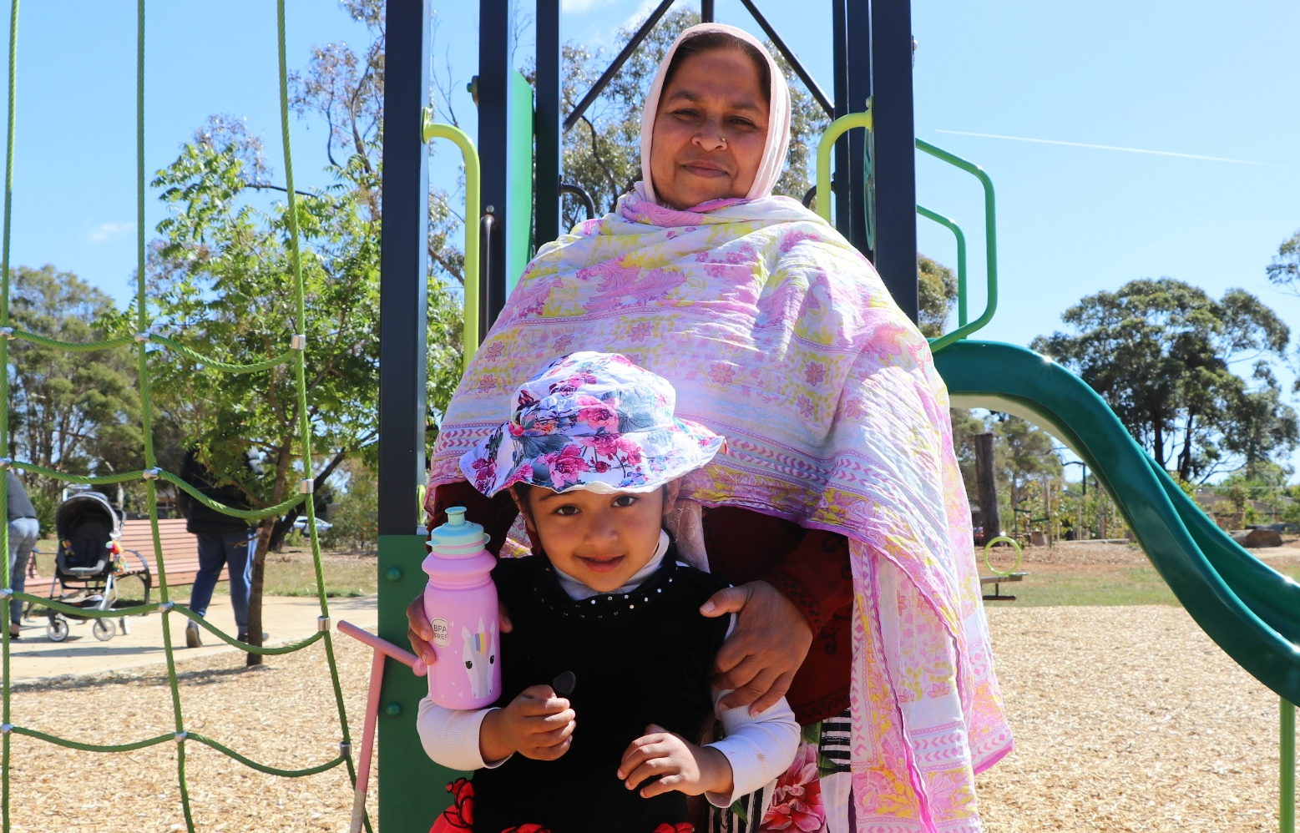

March 2024

PROJECT BACKGROUND:
Feedback was sought on Council's Advocacy Strategy 2024-2026. Priorities in the strategy are reviewed and updated quarterly and the most recent version was provided for feedback.
The engagement was open from 29 November 2023 through to 28 January 2024.
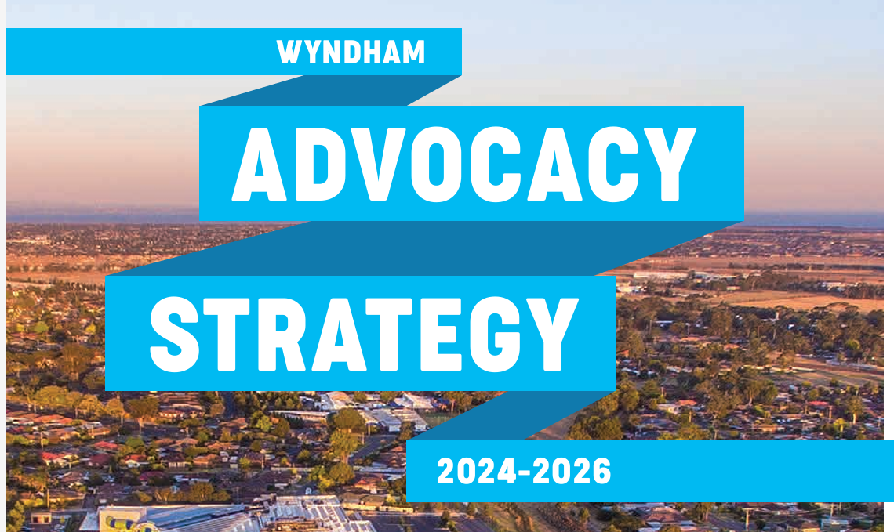

METHODOLOGY:
The below table outlines the various methods and techniques used to engage with the community.

Community engagement activities / tools
Method / technique Stakeholders engaged
Project page on The Loop | 1,157 total visitors to the page  1,669 page views
Online survey | 23 surveys completed
Online quick poll | 24 contributions to the quick poll
Other engagement | 2 Direct email response for key stakeholders

Communications / marketing activities
Method / technique | Stakeholders engaged
Online promotion (Facebook) | Reached: 45,098  Engagement: 1007  Click through to website: 864
Direct representations | We contacted a number a key stakeholder and asked them to provide direct feedback on the Advocacy Strategy. These include:  - National Growth Areas Alliance  - WoMEDA

SUMMARY OF FEEDBACK:

Who we heard from:
Age | % | Number
9-24 | 0% | 0
25-29 | 4.35% | 1
30-34 | 17.39% | 4
35-39 | 4.35% | 1
40-44 | 17.39% | 4
45-49 | 0% | 0
50-54 | 13.04% | 3
55-59 | 13.04% | 3
60-64 | 17.39% | 4
65-69 | 0% | 0
70-74 | 8.70% | 2
75-79 | 4.35% | 1
80-84 | 0% | 0
85 and over | 0% | 0
Total | 100.00% | 23

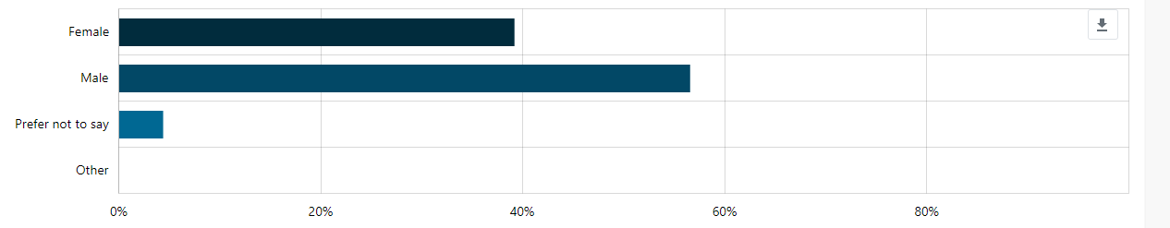

Suburb | Percent | Count
Cocoroc | 0% | 0
Eynesbury | 0% | 0
Hoppers Crossing | 17.39% | 4
Laverton | 0% | 0
Laverton North | 0% | 0
Little River | 0% | 0
Mambourin | 0% | 0
Manor Lakes | 4.35% | 1
Mount Cottrell | 0% | 0
Point Cook | 17.39% | 4
Tarneit | 8.70% | 2
Truganina | 8.70% | 2
Werribee | 13.04% | 3
Werribee South | 0% | 0
Williams Landing | 13.04% | 3
Wyndham Vale | 17.39% | 4
Quandong | 0% | 0
Other | 0% | 0
Total | 100.00% | 23

Feedback from online quick poll:
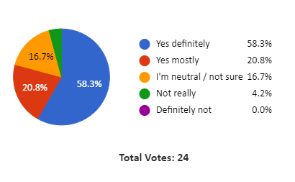

Feedback from online survey:

Do you support our Advocacy Strategy 2024-2026?
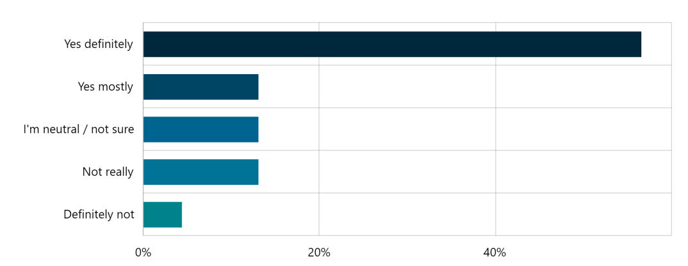
We asked:

You Said | We did / we’re doing
Good to see the council with a clear strategy. My only feedback would be the need to build a vibrant business community. There is so many business's in Wyndham and we need to create a central Chamber of Commerce or peak business body. | Wyndham City Council is working with local businesses and representative groups to promote local business, enhance the local business environment and encourage networking and cooperation.  We have a number of advocacy priorities to support local economic development. Our new Advocacy Strategy will provide a framework for assessing the required resources and timelines for achieving these priorities.
Infrastructure is in dire state. We need work on arterial roads most immediately. Wyndham Vale suburb in general needs transport infrastructure upgrade. Huge amount of residential being developed without support infrastructure for the same. | Wyndham City is actively advocating for improved investment in transport infrastructure to meet the growing needs of our community. Our Advocacy Strategy identifies how we allocate resources and techniques to advocate for a range of transport projects in Wyndham Vale including:  - West Link Stage 2 – construction of road across Werribee River between Wyndham Vale and Tarneit.  - Improvements to Ballan Road  - Addition railway station at Black Forest Road  - Rail extension between Wyndham Vale and Werribee, and  - Improved rail services on the Wyndham Vale line.
Stop wasting $$$$$$$$ and take a pay cut ?????? | No action required
Stick to what you are meant to do Roads, Rubbish, Rates | No action required
Would be good to add more of a social care and health focus especially around cancer and aged care. Transparency of communication could be better eg what happened to Point Cook hospital? | Wyndham City is actively working with the State and Federal Governments to improve access to health care for local residents.  Improved access to Maternal and Child Health was a key priority in the last State election, and we continue to advocate for improved access.
I hope to make central the strategy the reform to the transportation in Wyndham- More buses, more trains more often, | Better public transport remains a key advocacy priority for Wyndham City Council. Notably,  Better buses and more train services are key priorities under the new advocacy strategy.  Some of our advocacy key priorities include:  - Improve bus services across Wyndham including higher frequencies, extended hours of operation and responsive and flexible services  - Undertake biennial reviews of bus services to improve integration with trains and match service frequencies, hours of operation and extend service coverage to support population growth.  - Working with key stakeholders to support and deliver new and emerging technologies and transport innovations such as on demand services, utilisation of smart technology and innovative mapping/real time solutions.
It seems a bit of a facade since the CEO is employed by the government and will do whatever the government tells him to. You want to appear to engage with the community, and give the community the feeling they are being listened to, but the end result is the CEO will do whatever the Government says. | No action required
Add the following  * North extension of Forsyth rd, especially urgent to build the missing 500m of road to connect to Doherty’s rd. Right now a lot of traffic diverts across Alcock road and surrounding residential area  * Missing Bus lines: Right now, there is not a single public bus line serving to Albright neighbourhood (norther end of Alcock rd). At least one bus line to connect to the train station is urgently needed.  * Connection of walking/bike path along Doherty’s drain to corner of leaks rd and Forsyth rd. Right now is a dead-end walk  * Urgent development of Truganina train station!!! and surrounding area, including access from Forsyth rd and Doherty’s rd. It makes much more sense to build all projected train stations along the line, rather than keep expanding the parking of the existing Tarneit station  * Doherty’s rd widening between palmers and Morris rd, including better (safer) pedestrian/bike access to cross bridge over train line | Better public transport remains a key advocacy priority for Wyndham City Council. Our new Advocacy Strategy will enable us to better allocate resources to target key priorities including:  - Funding for addition railway station along the Wyndham Vale line including the proposed Truganina.  - Improved bus services  - Upgrades and duplication of arterial roads across Wyndham.  - Wyndham is working on a range of priorities to improve active transport accessibility. These priorities have been identified and assessed in Wyndham Active Transport Strategy 2020.
I would request you to look in to below projects as priority for residents living towards Doherty road.  * extension Forsyth rd to Doherty’s rd  * bus line Albright-train station (there is not a single bus stop in all Albright)  * connection walking path along Doherty’s drain to leaks road (right now is a dead-end walk, it would be nice to be able to walk to the KFC)  * Truganina train station!!!!  * Doherty’s rd widening | Better public transport remains a key advocacy priority for Wyndham City Council. Our new Advocacy Strategy will enable us to better allocate resources to target key priorities including:  - Funding for addition railway station along the Wyndham Vale line including the proposed Truganina.  - Improved bus services  - Upgrades and duplication of arterial roads across Wyndham. The duplication of the section between Palmers Road and Morris Road will require funding by State Government.  - Wyndham is working on a range of priorities to improve active transport accessibility. These priorities have been identified and assessed in Wyndham Active Transport Strategy 2020.  The majority of the land required for the extension of Forsyth Rd (between the current constructed section north of Leakes Road to Brightly Boulevard) is still located within private property. The landowner is currently undertaking planning for the next stages of the subdivision, which would provide the land for Forsyth Road as part of the approved subdivision permit. I cannot provide any timelines on when this will be completed or when this missing section of Forsyth Road would be constructed.
Build a road bridge over the Werribee River between Tarneit and Manor Lakes as a matter of substantial urgency to improve traffic flow and safety to and from new estate developments.  Get rid of roundabouts at corner of Derrimut and Hogans Roads; corner of Heath and Shaws Roads as well as corner of Tarneit and Heaths Roads. Replace them with traffic lights to improve traffic flow and safety. | Stage 2 of the WestLink project is a key priority for Wyndham City. We recognise the need for a river crossing connect Wyndham Vale/ Manor Lakes to Tarneit and the fast-growing employment precinct in Truganina.  The Advocacy Strategy will enable Wyndham to affective allocate resources and identify the best approach to lobbying the State and Federal Government to ensure this critical piece of infrastructure is built in a timely manner.
This is a very well thought out and measurable advocacy strategy. I was impressed with the criteria to ensure maximum effectiveness of our resourcing and the attention to stakeholder building.  The framework offers me confidence as a member of the community that there is a systematic approach, consistency, and alignment with overarching objectives, ultimately enhancing efficiency and effectiveness in decision-making.  I think you lack 3 major areas.  1. The possibility to leverage digital platforms to reach a broader audience and amplify your advocacy  2. Potential challenges and opposition to your advocacy and contingency plans (risk)  3. Refining and evaluating to ensure responsiveness and relevance | The use of digital platforms and social media are tools that have been used in the past to advocate improved investment and services. The new advocacy strategy aims to identify what are the best tools to advocate for each priority.  The Advocacy Strategy identifies a set of criteria that will be used to rank priorities and identify key actions.  This should assist staff in identifying which priorities will best suited to the use of social media campaigns.
The West of Melbourne Economic Development Alliance Inc. (WoMEDA) supports Wyndham City Council’s (Council) Advocacy Strategy 2024-2026 (Strategy).  WoMEDA’s board comprises key organisations from across the west of Melbourne such as Greater Western Water, Victoria University, Western Bulldogs and Western Health, as well as local councils of Maribyrnong and Brimbank in addition to Wyndham.  WoMEDA commends Council for undertaking an independent review of its existing advocacy strategy in 2023 to determine effectiveness and identify areas for improvement.  Given rapid population growth in the local government area (LGA) and pressure on existing infrastructure and services, the Strategy provides clear governance to the community, stakeholders and Council’s advocacy partners. With direct alignment to Council’s Wyndham 2040 Community Vision and links to other policies and strategies, the Strategy provides a robust foundation for Council’s advocacy locally and with broader advocacy partners.  Importantly, Council’s Advocacy Framework establishes clear roles and responsibilities, advocacy objectives, guiding principles and methodology for determining key priorities with clear assessment criteria – providing a sound basis for effective, productive and successful advocacy outcomes that benefit the community. The Action Plan identified provides further confidence to the community, stakeholders and advocacy partners that key priorities will be effectively and efficiently managed. | No action required
NGGA:  Key points from my perspective:  - Support the vision – it is aligned with the NGAA vision  - Articulating the levels of government is valuable as is articulating the levels of advocacy and partnerships (love the shout out to NGAA!)  - Assessment criteria – community impact: In addition to the number of residents who would be serviced, I suggest they add a line item about meeting specific cultural needs or specific needs of a subgroup of the community (i.e. newborn children). For example, a project may service 10pc of the overall Wyndham population but that may represent 100pc of a particular cultural or sub-group which would have a significant impact on their experience of Wyndham.  - Support the current advocacy priorities – again there is clear alignment with NGAA which is good to see!  - Actions (years 1-4) – The reference to taking an active role in strategic direction of the NGAA could also include participating in the committees. | No action required

NEXT STEPS:
- Council will use the feedback provided by this consultation to inform how we rank our advocacy priorities, allocate resources and campaign for additional funding and investment is services that enhance the liveability our Wyndham City.

HOW CAN PARTICIPANTS STAY INVOLVED/INFORMED?
Participants can stay informed by visiting the Loop page and selecting to “Follow” the project. Updates will be posted on The Loop and the project timeline will be updated to reflect project status.

