Draft
Accessibility & Inclusion Plan
2023 – 2025

Acknowledgement
To be inserted on the final version

Contents
Acknowledgement 2
Introduction 4
Vision 4
Legislative Context 5
Council’s Role 8
A focus on disability 8
Recognising Carers 15
Intersectionality 16
Community Engagement 16
Outcomes framework 16
Accessibility & Inclusion Plan Priorities and Outcomes 17
Monitoring and reporting on progress 19

Introduction
The Accessibility and Inclusion Plan responds to the Wyndham 2040 Community Vision, a place for people, by upholding the vision for a safe, connected and inclusive community. Through this plan Council commits to improving access and inclusion for people living with disability in Wyndham and their carers.
Human rights are universal. They are about being treated fairly, treating others fairly, social justice and inclusion. They apply to everyone, including people with disability, their families and carers. The United Nations Convention on the Rights of Persons with Disabilities (CRPD) applies human rights specifically to the context of people with disability in recognition of the barriers they face in realising their rights. The CRPD is underpinned by the human rights model of disability, which recognises disability as a natural part of the human condition.
Australia has ratified the CRPD making it unlawful to discriminate against a person with disability. Council is required under the Disability Act 2006 (s 38) to have a disability action plan.
Wyndham’s Accessibility and Inclusion Plan is centred around outcomes. The ‘outcomes’ are our end goals, the change we will work towards with the Plan. The outcomes framework will help to determine where we are having an impact in progressing accessibility and inclusion for people living with disability in Wyndham.
A primary objective of this Plan is to build confidence by facilitating equitable engagement and participation for people with disability in our community.
The goal is to provide the same level of access that people without disability enjoy and to ensure people are not discriminated against based on their disability.

Vision
The vision acknowledges the motto of Disabled Peoples’ International (DPI) which is ‘Nothing About Us, Without Us’. It was developed in consultation with community members with lived experience of disability and Wyndham City staff.
This vision was renewed from the previous Wyndham City Accessibility Action Plan 2019-2022:
“People with disability, our families and/or carers experience dignity, respect and inclusive access to opportunities and services. Our voice is respected, we have control over our lives, and disability pride and diversity are celebrated.”

Legislative Context
Wyndham’s Accessibility and Inclusion Plan fits within several legal frameworks and social policies at an international, national, state and local level that aim to ensure the rights of people with disability are upheld and protected. A brief description of how this Plan aligns with the National and State Disability Plans, and Council policy hierarchy is provided below.

  - Victorian Government
Under Victorian law a disability is defined as:
- the total or partial loss of a body part or a body function (such as mobility, sight or hearing)
- disfigurement
- mental health disorders
- learning difficulties.
Under the Victorian Disability Act 2006 (the Act), all Victorian public sector bodies must prepare a disability action plan to be lodged with the Victorian Equal Opportunity and Human Rights Commission addressing the following key areas:
- Reducing barriers to people with a disability in accessing goods, services and facilities
- Reducing barriers to people with a disability in obtaining and maintaining employment
- Promoting inclusion and participation of people with a disability in the community
- Achieving tangible changes in attitudes and practices which discriminate against people with a disability.

  - Disability Inclusion Bill
The Victorian Government is reviewing the Disability Act 2006 to ensure the legislation is contemporary and fit-for-purpose, especially in light of the National Disability Insurance Scheme (NDIS).
The new Disability Inclusion Act would sit alongside the Disability Act and proposes a Commissioner for Disability Inclusion to promote and monitor progress in advancing disability inclusion and embed the social model of disability in Victoria, as well as new accountabilities and alignment between the tiers of government.
The Disability Inclusion Bill would replace the current provisions in the Disability Act in relation to the State Disability Plan, Disability Action Plans and the Victorian Disability Advisory Council, and create a new legislative framework for whole-of-government action and accountability in pursuing disability inclusion in Victoria. Under the proposed legislation disability inclusion means a process intended to achieve equality between persons with disability and other members of the Victorian community.

  - Disability Act 2006
The State is required to prepare a Disability Plan under the Disability Act 2006 (s 37). Inclusive Victoria – State Disability Plan (2022-2026) is Victoria’s plan for making our community inclusive and accessible for everyone.
Aligning Council’s plan with the state plan enables Wyndham community priorities to also reflect state priorities. The priority areas of Inclusive Victoria are organised under four pillars:
- Inclusive communities
- Health, housing and wellbeing
- Fairness and safety
- Opportunity and pride
Inclusive Victoria has six systemic reform areas to help make sure government departments work together to reach the goals in the plan. These are:
- Co-design with people with disability
- Aboriginal self-determination
- Intersectional approaches
- Accessible communications and universal design
- Disability confident and inclusive workforces
- Effective data and outcomes

  - Commonwealth Government
Australia’s Disability Strategy 2021-2031 is a national framework that all governments in Australia have signed up to. The Strategy supports Australia’s commitment under the United Nations Convention on the Rights of Persons with Disabilities.
The Strategy’s vision is for an inclusive Australian society that ensures people with disability can fulfil their potential as equal members of the community. It is designed to drive change in seven outcomes areas:
- Employment and financial security
- Inclusive homes and communities
- Safety, rights and justice
- Personal and community support
- Education and learning
- Health and wellbeing
- Community attitudes

  - Wyndham City Council
Wyndham’s Plan aligns very closely with both the State and Federal Government Strategies. This alignment assists us in working together for collective impact where local priorities reflect state and national priorities. This approach has the intentional benefit of using similar indicators to measure progress over time and to access the same data sources.
The pillars of this Plan align with the themes of the Wyndham 2040 Community Vision, Wyndham City’s Council Plan, and the Municipal Public Health and Wellbeing Plan.

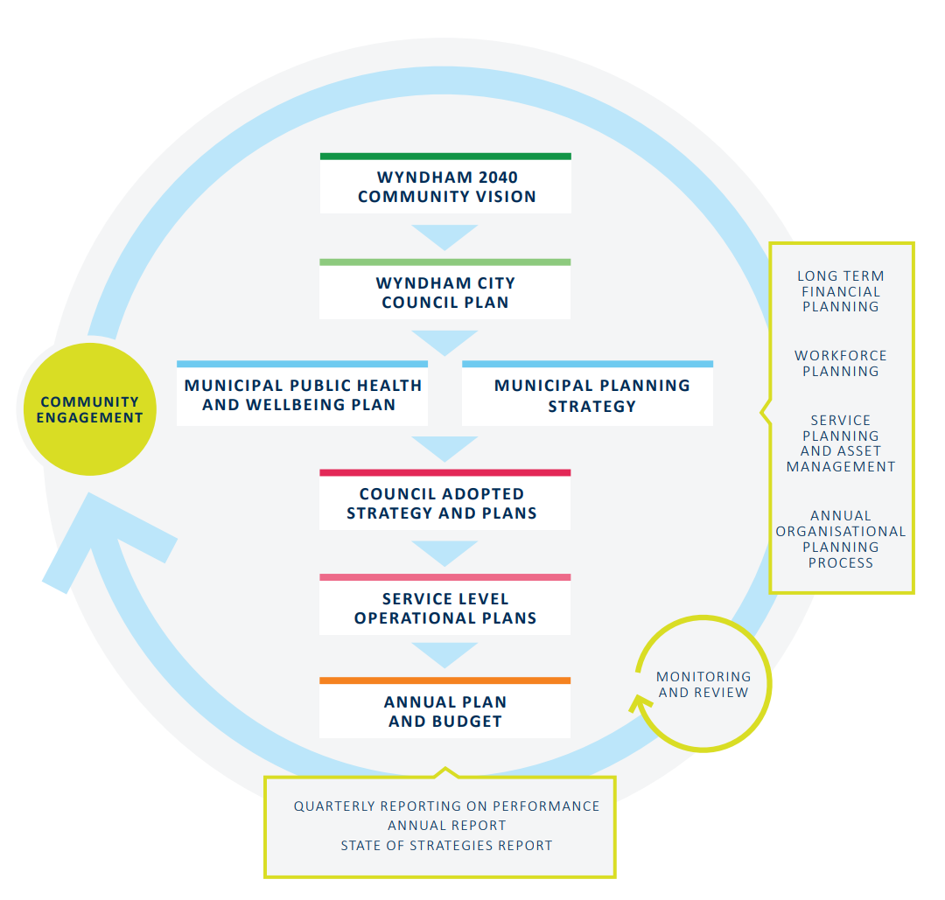

Figure 1 - Hierarchy of Council Plans

Council’s Role
Council acts within a range of roles to improve accessibility and inclusion for people living with disability in Wyndham. These roles include:
- Service Provider - Provides services including maternal and child health, libraries, early years services, youth services and many other community services and programs.
- Planner - Works to understand the current and future needs of the municipality and to set the overall direction for Wyndham through long-term planning which guides Council activities and resourcing.
Plans, designs, constructs and maintains buildings, open spaces, recreational facilities, and the local road/footpath/cycle network.
- Advocate - Works with relevant stakeholders and Federal and State Governments to ensure that funding is committed to provide services for everyone in the Wyndham community including people with a disability.
- Capacity Builder/Broker - Plays a key role in disseminating information and in connecting local service providers through the facilitation of networks and the maintenance of information sharing systems.
- Partner- Works in collaboration with a broad range of stakeholders to improve outcomes for our residents and municipality.

A Focus on Disability
Disability is part of being human. Almost everyone will temporarily or permanently experience disability at some point in their life. The number of people with disability across the world is increasing due in part to population ageing and an increase in the prevalence of noncommunicable diseases.
People with disability are diverse in their culture, language, sexuality, gender identity, age, ability, socioeconomic status and life experiences. They are parents, children, young people, and older people, and live in all communities. Their experiences and the way they perceive the concept of disability differ.
Wyndham’s Accessibility and Inclusion Plan is based on the social model of disability articulated in the United Nations’ Convention on the Rights of Persons with Disabilities, which recognises that disability results from the interaction between persons with impairments and attitudinal and environmental barriers that hinder their full and effective participation in society on an equal basis with others.
The inclusion of people with a disability is critical to achieving the Sustainable Development Goals and global health priorities to achieve health for all. The social model of disability puts the onus on society to adapt our environments, attitudes, policies and practices to remove barriers to ensure equal participation for everyone.
The United Nations (UN) provides the following definitions.
Persons with disabilities are:
…those who have long-term physical, mental, intellectual or sensory impairments which, in interaction with various barriers, may hinder their full and effective participation in society on an equal basis with others (CRPD, art. 1).
Disability inclusion is defined as:
The meaningful participation of persons with disabilities in all their diversity, the promotion of their rights and the consideration of disability-related perspectives, in compliance with the CRPD.
Accessibility is defined as:
Ensuring that persons with disabilities have access, on an equal basis with others, to the physical environment, to transportation, to information and communications, including information and communications technologies and systems, and to other facilities and services open or provided to the public, both in urban and in rural areas (CRPD, art. 9).
Universal design:
The design of products, environments, programs and services to be usable by all people, to the greatest extent possible, without the need for adaptation or specialised design. Universal design shall not exclude assistive devices for particular groups of persons with disabilities where this is needed (CRPD, art. 2).
Discrimination on the basis of Disability:
Any distinction, exclusion or restriction on the basis of disability that has the purpose or effect of impairing or nullifying the recognition, enjoyment or exercise, on an equal basis with others, of all human rights and fundamental freedoms in the political, economic, social, cultural, civil or any other field. It includes all forms of discrimination, including denial of reasonable accommodation (CRPD, art. 2).
The term disability in this plan, is intended to have a broad and inclusive meaning that encompasses all forms of sensory, physical, cognitive, neurological, developmental and psychosocial disabilities (including mental health issues). We respect individuals lived experience who do not identify with the term disability in relation to themselves.
  - Accessibility and inclusion aim
The primary aim of Wyndham Accessibility and Inclusion Plan is to remove and reduce barriers and facilitate full community participation.

  - Statistical data
The Australian Bureau of Statistics Census of Population and Housing counts people with a need for assistance with core activities, identifying those with profound or severe core activity limitations. This can mean an underrepresentation of the numbers of people who sometimes needs help with communication, body movement or self-care, as not everyone who may have a disability identifies with these categories.
Information is collected in each national census about respondent’s ‘need for assistance’ with either ‘self-care’, ‘body movement’ or ‘communication’ activities. In 2021, there were 12,100 people (or 4.1% of the total population) with a need for assistance living in the City of Wyndham. Figure 2 illustrates the percentage of the population in each Wyndham suburb of people with a need for assistance.
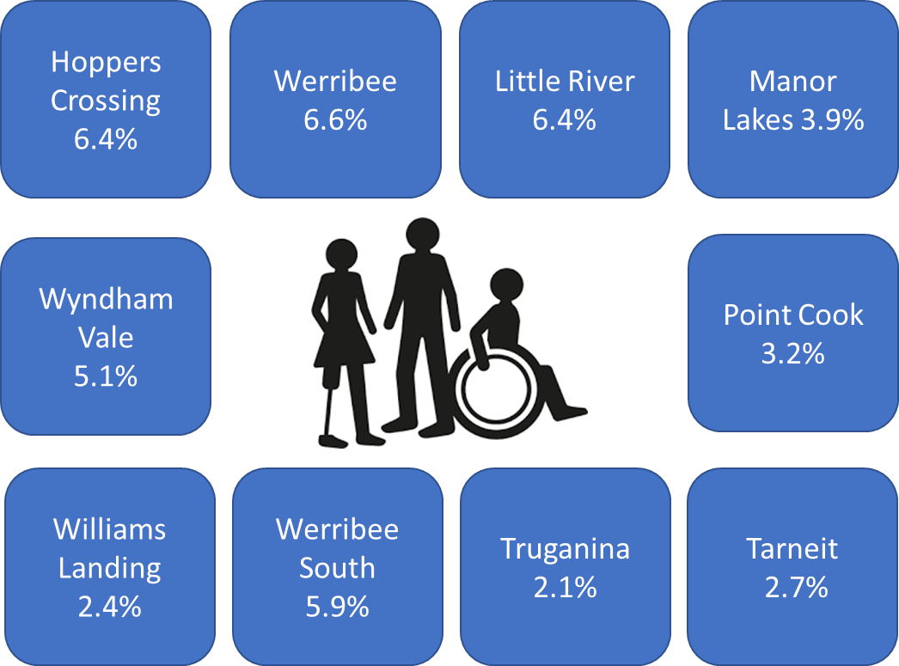
Figure 2 - People with Disability in Wyndham suburbs
Analysis of the population needing assistance in the City of Wyndham in 2021, compared to Greater Melbourne, shows that there was a higher proportion of people in the younger age groups (under 15) and a lower proportion of people in the older age groups (65+).
The number people in private dwellings reporting a need for assistance in City of Wyndham increased by 3,453 between 2016 and 2021.
Overall, 19.9 per cent of the population needing assistance was aged between 0 and 14, and 38.9 per cent were aged 65 years and over (compared with 10.1% and 56.7% respectively for Greater Melbourne).
Analysis of the household/family types of people reporting a need for assistance in the City of Wyndham in 2021, compared to Greater Melbourne, shows that there was a higher proportion of people needing assistance in couple families with child(ren) as well as a higher proportion in one-parent families. Overall, 44.4 per cent of people reporting a need for assistance were in couple families with child/ren (compared with 32.6% for Greater Melbourne).
In Wyndham, there was a lower proportion of people reporting a need for assistance in lone person households and a lower proportion in couples without children. Overall, the proportion of people with a need for assistance in lone person households was 10.9 per cent (compared to 19.1% in Greater Melbourne). The proportion in couples without children was 18.8 per cent (compared to 24.5% in Greater Melbourne).
239 people identifying as Aboriginal and Torres Strait Islanders in Wyndham have a disability. This number represents 10.2% of Indigenous residents.
The size of Wyndham's labour force needing assistance in 2021 was 1,248, of which 485 were employed part-time and 392 were full time workers. Overall:
- 83.2 per cent of the labour force needing assistance was employed, and 16.8 per cent unemployed (compared with 86.6% and 13.4% respectively for Greater Melbourne).
- 12.8 per cent of people reporting a need for assistance were in households who earned a high income, and 18.4 per cent were in low income households (compared with 12.1% and 24.7% respectively for Greater Melbourne).
- 15.5 per cent of the population needing assistance provided unpaid childcare, (compared with 9.4% for Greater Melbourne).

  - National Disability Insurance Scheme (NDIS)
National surveys show that intellectual impairment is a prevalent form of disability among children. In older age physical restrictions and sensory impairments become more widespread
There are 7,205 NDIS participants in Wyndham. Figure 3 below shows the number of active NDIS participants, those who have been determined eligible and have an approved plan. Figure 4 shows primary disability.

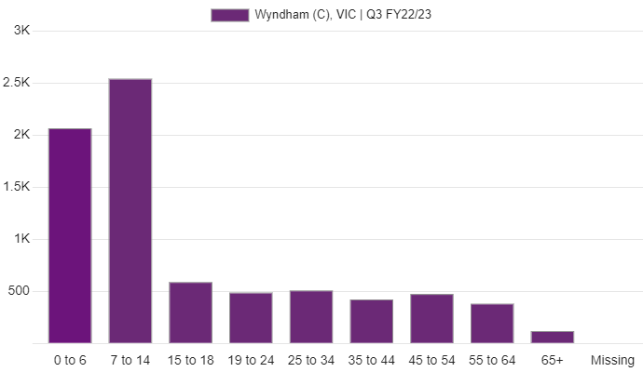
Figure 3 - Active Participants by Age Group
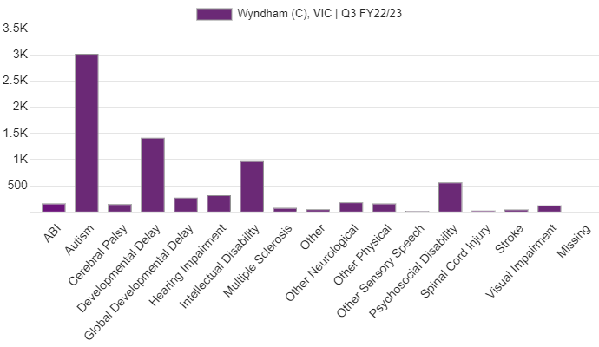
Figure 4 - Active participants by Primary Disability
  - Other Statistical Data
The Australian Institute of Health and Welfare provides statistics relating to participation, need for assistance and social outcomes of people living with disability. Although the data is at a national level (not specific to Wyndham) it provides overarching information about people living with disability in Australia relating to participation, need for assistance and outcomes, as shown in the three summary tables below.
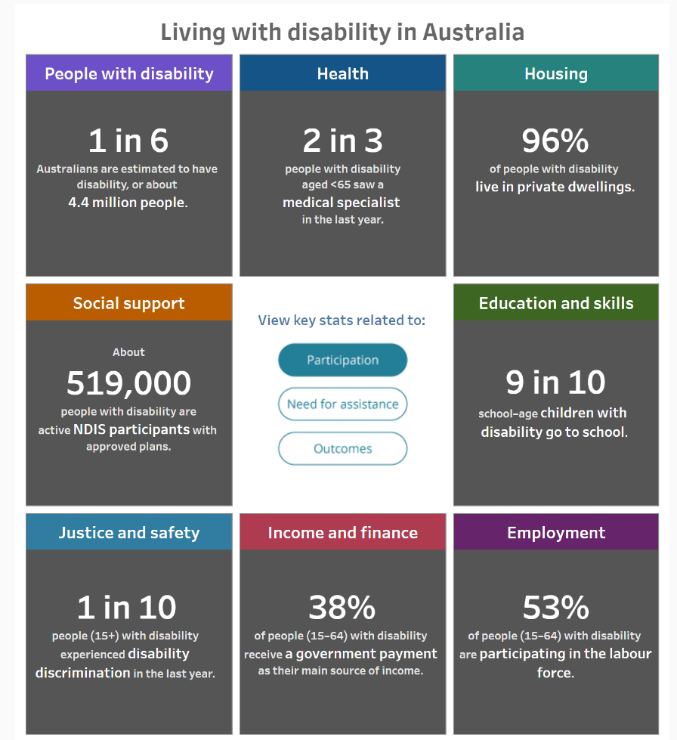
Please note that definition of disability for this data count differs from the ‘need for assistance’ criteria used in the Census data, and therefore prevalence of disability is higher than the statistics from the ABS Census above.

Figure 5 - Source AIHW, 2022.

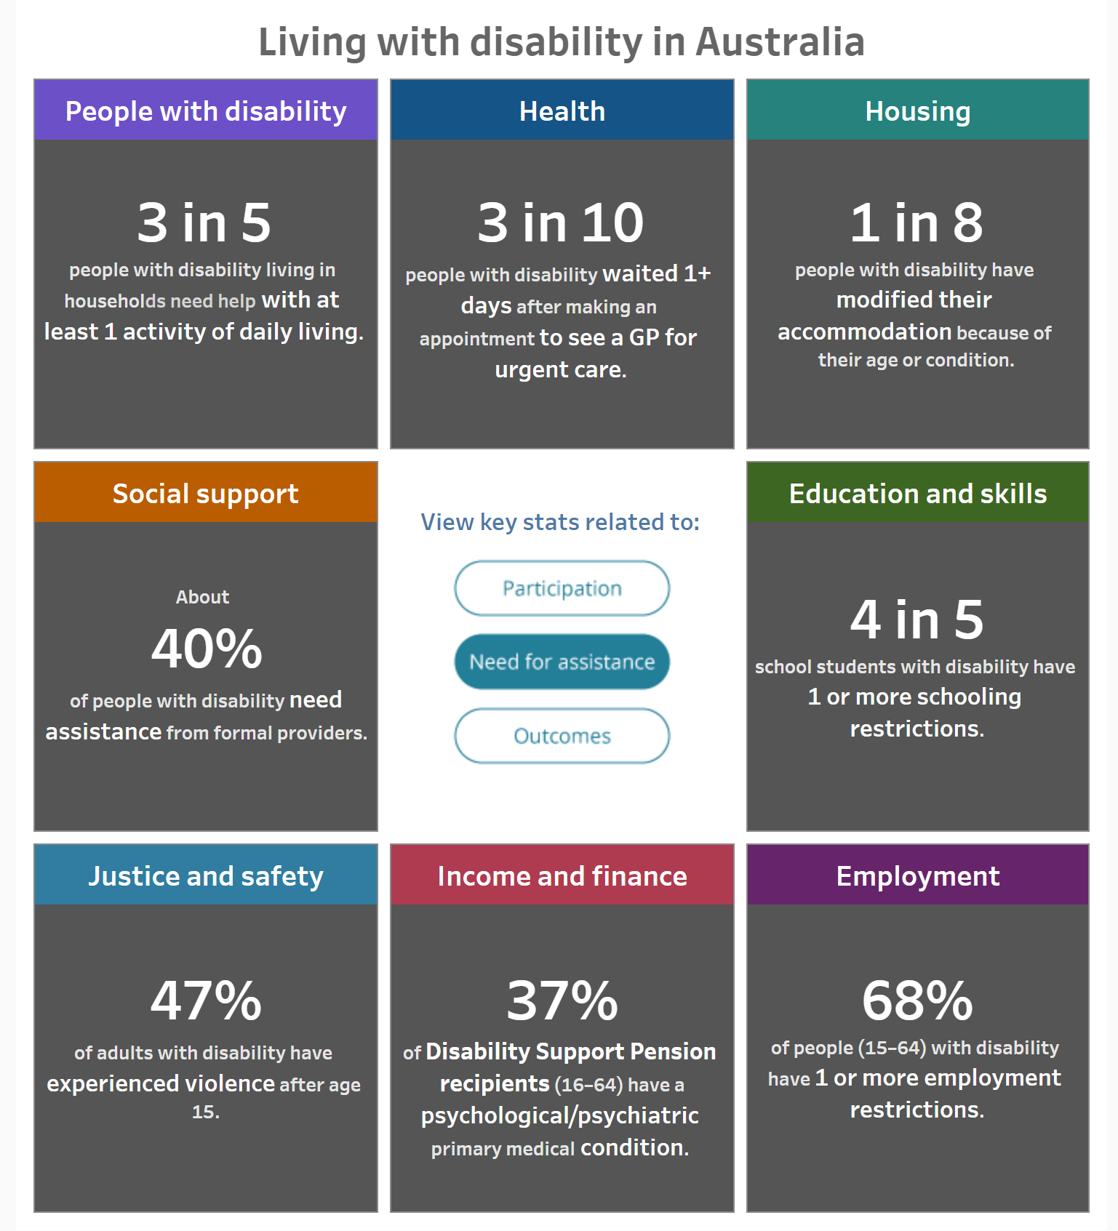
Figure 6 - Source AIHW, 2022.

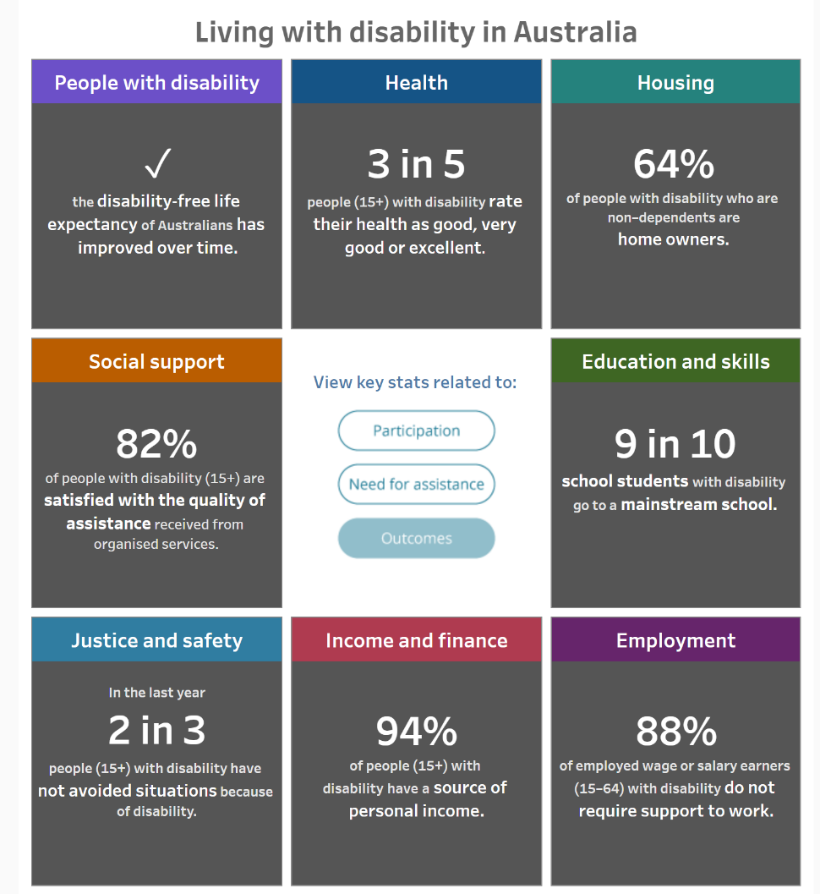
Figure 7 - Source AIHW, 2022.

Recognising Carers
The Victorian Carers Recognition Act 2012 formally acknowledges the important contribution that people in care relationships make to our community and the unique knowledge that carers hold of the person in their care. The Act recognises the principles of respect, consideration, recognition and support for Council to embed when working with carers and the people that they care for.
Wyndham’s Accessibility and Inclusion Plan respects and recognises carers who are staff members or community members and promotes due consideration of carers when progressing accessibility and inclusion in Wyndham.

Intersectionality
We aim to recognise the importance of understanding, acknowledging and celebrating the diversity of people with disability in our Plan. This includes an understanding of intersectionality as the potential for people to experience disadvantage due to the intersection of their sex, age, race, culture, gender identity, sexual orientation, impairment, disability status, socioeconomic status, religion and other dimensions. In practical terms, this means that 40-year-old female with a disability may face different challenges to an 18-year-old male with the same disability.
These dimensions are connected; each informs the other with overlapping and compounding effects. We will continue to reflect on intersectionality through implementation of the Plan and seek out supporting data to measure progress as it becomes available.
People with a long-term health condition or disability have been one of the groups identified in the Wyndham Lifecourse Framework since this group can experience poorer health and difficulty in accessing health care they require. This group is prioritised due to economic and social inequalities that deepened during the health crisis, producing greater inequality.

Community Engagement
Community helped to inform this Plan through discussion on refreshing the vision of the Plan, and on drafted pillars and priorities. Consultation engagement presented draft pillars and priorities that sought alignment between the Community Vision, Council Plan and Council’s Municipal Health and Wellbeing Plan, drawing upon other extensive community engagement that preceded development of this Plan.
Targeted consultations included feedback on the draft priorities from Wyndham’s People’s Advisory Panel. This also included an open invitation to people with lived experience in Wyndham (who may not be Panel members), as well as workshops with appropriate networks.
Engagement across the organisation will be ongoing to identify and action opportunities over the duration of the Plan to make progress against the identified outcomes and improve access and inclusion in Wyndham. Formal engagement during implementation will again include the Wyndham’s Peoples Advisory Panel, as the primary platform for engagement on specific issues.

Outcomes Framework
The framework articulates the themes that align with other overarching strategies and plans, and details community priorities, the outcomes that are the commitment for progress, and how progress will be measured.
The framework is defined by four high level pillars that align with the themes/pillars/domains in Australia’s Disability Strategy, the State Disability Strategy, the Wyndham Council Plan and the Municipal Public Health and Wellbeing Plan.
Each of the four pillars state the community priorities that embody the pillars. Importantly, an outcome is articulated against each of the priorities. These outcomes are the basis of this Plan – we are committed to making progress against each outcome area. Therefore, we must be able to measure any progress over time of each outcome.

Wyndham 2040 Community Vision Themes | Wyndham Health Plan Domains | Draft Accessibility and Inclusion Plan  Pillars | Victorian State Plan  Pillars
People & community | Thriving Wyndham | Thriving | Inclusive communities
Places & Spaces | Liveable Wyndham | Healthy | Health, housing & wellbeing
Earning & Learning | Safe Wyndham | Safe | Fairness & safety
Leadership & Participation | Healthy Wyndham | Opportunity | Opportunity & pride

It is important to note that outcomes are intentionally aligned with the state and federal plans for collective impact in social policy. This will reduce the need to create additional local measures which can be resource intensive, over-consultative, and at risk of not meeting statistical significance.
Some data measures are therefore reliant on statistical data that may not align well within the timelines of the Plan for baseline and progress measures. This is acknowledged as one of the areas to learn from through the implementation and evaluation of this Plan and to provide feedback to the Victorian Government on challenges and opportunities to align defined entities for collective impact and measuring progress.

Accessibility & Inclusion Plan Priorities and Outcomes

PILLAR | PRIORITIES | OUTCOMES | COUNCIL’S ROLE
THRIVING | Community attitudes | - People with disability feel included and enjoy greater social connection | Capacity Builder/Broker, Partner,
 | Accessible services | - People with disability can readily access the services they need | Capacity Builder/Broker, Partner, and Service Provider
 | Accessible information | - People with a disability have access to information that meets the user needs | Advocate, Capacity Builder/Broker, Partner, and Service Provider
 | Education | - Children with a disability are provided with the supports required to begin school  - People with a disability have access to formal and informal learning opportunities regardless of their ability | Service Provider and Advocate  Service Provider, Capacity Builder/Broker, Partner, and  Advocate
 | Employment & economic participation | - People with disability can get and maintain jobs that meet their needs and improve their lives | Capacity Builder/Broker, Partner, and Advocate
HEALTHY | Health | - People with disability enjoy greater wellbeing including access to healthy food options | Capacity Builder/Broker, Partner, and Advocate
 | Mental health | - People with disability report improved mental wellbeing | Planner, Advocate, and Partner
 | Accessible housing | - People with disability can access affordable housing built to universal design standards | Advocate, Planner
 | Accessible built & natural environments | - People with disability can navigate urban and natural environments regardless of their age, ability, gender, identity, culture, language, or any other social characteristic | Service Provider, Planner and Advocate
SAFE | Emergency preparedness | - People with disability can access emergency communications (e.g. during fire, flood, etc.) | Capacity Builder/ Broker, Partner, and Service Provider
 | Preventing abuse & neglect | - People with disability are protected against abuse and neglect | Capacity Builder/Broker, Partner, and Advocate
OPPORTUNITY | Voice & leadership | - People with disability can exercise their civic rights and responsibilities regardless of their intersectionality (e.g. First Nations, multicultural and LGBTIQ+) | Service Provider, and Planner
 | Pride & recognition | - People with disability are recognised and celebrated regardless of their age, ability, gender, identity, culture, language, or any other social characteristic | Advocate, Capacity Builder/Broker, and Partner

Monitoring and reporting on progress
Organisational business units will be required to provide quarterly updates on progress against outcomes to Councillors, which will inform annual reporting to community using the outcomes framework.
The outcomes are high level and progress can be incremental and over an extended period. To address this, a narrative of actions taken will be provided in addition to the metrics of success.
This Plan will contribute to collective impacts across levels of government, including through access to reliable data that demonstrate the real progress of disability inclusion. This will help to address instances where data sources that measure progress may not be available at a municipal level. Where this data is not available metrics of success will include the actions taken by Council to contribute to the achievement of the outcome.

Australian Government Attorney-General’s Department, Rights of people with disability. Public sector guidance sheet. Accessed 1 May 2023: https://www.ag.gov.au/rights-and-protections/human-rights-and-anti-discrimination/human-rights-scrutiny/public-sector-guidance-sheets/rights-people-disability
PWDA Language Guide: A guide to language about disability, Aug 2021 Update. Accessed 1 May 2023: https://pwd.org.au/wp-content/uploads/2021/12/PWDA-Language-Guide-v2-2021.pdf
Victorian Equal Opportunity & Human Rights Commission, What is disability discrimination? Accessed 1 May 2023: https://www.humanrights.vic.gov.au/for-individuals/disability/
Victorian Disability Act 2006, www.legislation.vic.gov.au
World Health Organisation (WHO), Disability. Accessed 1 May 2023: https://www.who.int/health-topics/disability#tab=tab_1
Ibid
Inclusive Victoria – State disability plan 2022 - 2026
United Nations, Convention on the Rights of Persons with Disabilities
WHO as at 5
United Nations Disability Inclusion Strategy. Accessed 1 May 2023: https://www.un.org/en/content/disabilitystrategy/
Statistics sourced from the NDIS Data and insights page; third quarter 2022-2023. Accessed 14 June 2023: https://data.ndis.gov.au/data-downloards#participant
Australian Institute of Health and Welfare – People with disability in Australia, Summary, 2022-7-5 AIHW - People with Disability in Australia
Carers Recognition Act 2012

