Wyndham Gambling Harm Minimisation Policy and Action Plan 2018-2022
Here

Foreword from the Mayor
It gives me great pleasure to introduce Wyndham City’s Gambling Harm Minimisation Policy and Action Plan 2018-2022.
Our Council has a long-standing commitment to reduce the harms associated with all forms of gambling, especially Electronic Gaming Machines (EGMs) and recognises the cost to our community is not just financial loss, but also has devastating impacts on the health and wellbeing of individuals, families and businesses throughout our City.
In the 2016/2017 financial year our community lost over $97 million dollars on EGMs. This policy outlines our position on gambling and reflects the community’s concerns regarding gambling and its effects on the wellbeing of the community.
Our Gambling Harm Minimisation Policy vision is to protect and promote the health and wellbeing of all Wyndham residents by preventing the harms associated with gambling and has the following goals:
- Advocate in partnership with community for systemic and legislative change to address gambling harm.
- To take a whole of organisation approach and partner with community in preventing and minimising gambling harm and promoting health and wellbeing.
- To enable community engaged and informed assessment of current and proposed gaming activity, particularly in the regulatory process.

Together with the action plan, this document outlines our objectives for the short and long term, including reducing the number of EGMs in Wyndham.
The issues of gambling are a whole-of community responsibility, and we look forward to working with residents, local venues, service agencies, the Alliance for Gambling Reform and other stakeholders to improve the health and wellbeing of our community.

Councillor Peter Maynard
Mayor

Foreword from the Chair of Wyndham Gambling Harm Minimisation Reference Group
Council sees the harms of gambling as a public health issue which has significant impacts on individuals, families and communities.
This Gambling Harm Minimisation Policy and Action Plan has been developed from a strong evidence base. It takes account of emerging trends and learnings since this Council’s former gambling strategy was developed.
It was important to me in developing this Policy and Action Plan that it reflected community concerns and voices regarding gambling in our municipality. I am also pleased that it expands our focus from Electronic Gaming Machines to also include commitments to address areas of online and sports betting.
We are dedicated to continuing to engage with our local community in taking positive ownership of the issue, decreasing stigma, encouraging help-seeking and participation in gambling-free community spaces and activities.
As Chair of Wyndham Gambling Harm Minimisation Reference Group, I would like to take this opportunity to acknowledge and thank all members of the Reference Group for their valuable contribution to the development of The Gambling Harm Minimisation Policy and Action Plan.
- Rose Babic (Victorian Responsible Gambling Foundation)
- Denis Nelthorpe (Westjustice)
- Carol Muir (formerly of Uniting Wyndham)
- Ian Ferretter (IPC Health)
- Carlos Poveda Rayo (Anglicare)
- Mae Sie Win (Wyndham Community and Education Centre)
- Dimity Gannon (formerly of Health West)
Their strategic advice has resulted in a robust document that can be implemented and address the devastating impacts caused by gambling on the health and wellbeing of individuals, families and businesses in our City.
I look forward to seeing this Policy and Action Plan implemented and to working with the Wyndham community to create a fairer society where social and economic harm from all form of gambling are addressed.

Councillor Josh Gilligan
Chair Wyndham Gambling Harm Minimisation Reference Group

Introduction

Gambling is a multi-faceted industry that includes lotto, ‘scratchies’, table games, racing, sports betting, electronic gaming machines (EGMs) and online gambling. EGMs are the most dominant source of financial loss and harm from gambling in Australia.
Harm from gambling impacts not only the player (the individual), but also affects family members, friends, local businesses and communities.

Local government has legislative requirements to protect and promote the health and wellbeing of the community. This includes protecting communities from the risks and harms associated with gambling. Local government’s influence on gaming is twofold, the Wyndham Planning Scheme is Council’s regulatory response, while this new Wyndham Gambling Harm Minimisation Policy 2018 - 2022 and action plan will provide a means to address social issues.
The Gambling Harm Minimisation Policy and Action Plan 2018-2022 replaces Council’s two previous position statements, the Electronic Gaming Machine Policy adopted in 2010 and Wyndham City’s Responsible Gambling Strategy 2012-2014 adopted in 2012. The focus of this policy is on EGMS, online gaming and sports betting. Developed from a public health perspective and based on best evidence and data, the policy seeks to minimise the impact of gambling on the Wyndham community; facilitate transparent and consistent responses to applications to relevant statutory authorities and work in partnership with service providers and residents to minimise gambling associated harm and advocate for policy and legislative change.
The document is in two parts:
Part 1: The policy and action plan: This outlines the vision, goals and objectives that will guide Council’s actions over the next 4 years together with implementation actions for each objective.
Part 2: The evidence base: This provides an overview of the evidence base that underpins the policy and action plan.

Context

The Gambling Harm Minimisation Policy and Action Plan has been developed with a strong evidence base and to take account of emerging trends and learnings since the former gambling strategy was developed. Key factors are summarised below as context to the Policy with more detail available in Part 2: The Evidence Base.
A growing Wyndham
The population of Wyndham has grown by over a third since 2012, with almost 60,000 new residents moving to the area. Wyndham is a dynamic, diverse and vibrant community with many strengths. Its fast-paced growth also brings challenges, with infrastructure and services struggling to keep up. There are indicators that a significant proportion of the Wyndham population are facing socio- economic disadvantage; unemployment is higher than Greater Melbourne and Victoria; and there are high levels of rental evictions and mortgage delinquency, as well as growing levels of family violence.
Recent research shows that harm caused by gambling is disproportionately concentrated among Victorians who are experiencing multiple disadvantages. This harm was assessed to be above that of diabetes or arthritis, and equivalent to two thirds of the harm caused by depression.
Harms of gambling
In April 2016 the Victorian Responsible Gambling Foundation (VRGF) released ‘Assessing gambling related harm in Victoria’, a comprehensive report detailing the full breadth of gambling related harm experienced among the Victorian population.
The report divides gambling related harm into the following seven areas:
- Financial harm
- Relationship disruption,
- Emotional or psychological distress
- Detriments to health
- Cultural harm
- Reduced work or study performance
- Criminal activity

The report also found that the severity of gambling related harm increases according to at-risk gambling status. Of the total burden of gambling related harm in Victoria, the majority of harm was due to low and moderate risk gambling (85%) rather than problem gambling. This is due to the greater number of low and moderate risk gamblers in the Victorian population. So, while problem gamblers experience a greater severity of harm, the gambling behaviours of low and moderate risk gamblers has a larger impact on the Victorian population.

A public health approach
Since 2012 when Wyndham’s former gambling strategy was framed in terms of “responsible” gambling, there has been a significant shift in conceptualising harm caused by gambling. It is now seen as a public health issue. The focus has moved away from the individual and individual “responsibility” to the gambling product. Now, rather than seeing EGMs as a legitimate recreational activity that has negative impacts on a few, the focus is on seeing an industry that misleads users and creates an unacceptable risk of harm to the whole community. It shifts language and looks at a systemic approach to ameliorating harm.

This outlook is incorporated within Wyndham’s City Plan which adopts a social model of health, recognising that many factors influence both the health and wellbeing of individuals and of the community as a whole. Wyndham’s commitment to public health and wellbeing priorities includes the strategic objective:
Council will work with the community to ensure Wyndham is an inclusive, safe and welcoming city, which celebrates our diverse heritage and cultures and helps residents to stay healthy, active and connected.

The City Plan Strategy 1.2 states that “Council will endeavour to increase health and wellbeing outcomes of our community by engaging with the State and Federal Governments on gambling reform and reducing harmful alcohol and drug use, particularly among young people and other at risk community cohorts.”

The greatest source of gambling harm - EGMs in Wyndham
EGM gambling remains the primary source of harm from gambling with referrals to Gamblers Help Services indicating that 75-80% of clients use EGMs as their primary means of gambling. This is evidenced in the following snapshot statistics where Wyndham
• is ranked 8 of 70 LGAs for EGM losses in Victoria
• has an average loss of $599 per adult This is above the Victorian and Melbourne Metro average of $562 per adult
• has total losses for 2016-2017 of $97.8 million
• VCGLR figures also show that gambling losses by Wyndham adults are increasing at a far faster rate than Victoria (3.1% to 0.4%, adjusted for inflation)
Currently in Wyndham there are 893 EGMs across 13 venues, equating to 5.5 machines per 1,000 adults. This is higher than the Victorian and Melbourne metropolitan average of 5.2 machines per 1,000 adults.
In September 2017, the Victorian State Government gazetted new regional and municipal caps for Victorian Municipalities. This includes the introduction of a regional cap for Wyndham. This will cap the number of EGMs allowed in Hoppers Crossing, Laverton North, Manor Lakes, Werribee, Williams Landing and Wyndham Vale to 834. The remaining areas of Point Cook, Tarneit, Little River and Truganina will be covered by municipal caps of 552 entitlements. The reforms allow for an increase of up to 15 per cent in those suburbs not covered by the cap. The proposed changes could see the number of EGMs increase from a current maximum number of 1190 to 1368 in those suburbs with the associated risk of increased gambling harm in those areas. It is time for a strengthened policy position to support Council’s advocacy that the entire Wyndham municipality be capped at the current number of EGMs.
The role of Local Government
Under the Local Government Act 1989, councils are responsible for monitoring the long term and cumulative effects of planning decisions to ensure the best outcomes are achieved for their communities. As the closest level of government to the community, local government is in a good position to understand the effects of gambling and to limit the negative impacts of gambling on their communities.
Local government has an important role in managing the impacts of gambling in local communities, particularly gambling on EGMs. The Planning and Environment Act 1987 and the Wyndham Planning Scheme give Council the authority to assess applications for planning permits for gaming venues and EGMs within the municipality. The Gambling Regulation Act 2003 enables local government to make submissions to the Victorian Commission for Gambling and Liquor (VCGLR) in the form of a social and economic impact assessment (SEIA) for potential new applications for EGMs within its municipality or a neighbouring municipality.
In 2014, the Electronic Gaming Policy was adopted and incorporated into the Wyndham Planning Scheme Clause 22.03. The objective of this policy is to guide decision making in the location, design and operation of EGMs and gaming venues and identify locations where EGM venues are prohibited. Although a review of this policy was not within scope of the development of Wyndham’s Harm Minimisation Policy and Action Plan there are intrinsic links between Council’s regulatory and social roles policy responses. A proposed action is to review Clause 22.03 in light of the outcomes of the Policy and Action Plan process.
Another theme has been the realisation that active community participation in planning decisions for gaming is of fundamental importance and that Councils can play a key role in enabling this.
Growth of online gambling and sports betting
Since 2012, there has been rapidly growing participation in online gambling and sports betting. The potential impacts on young people are particularly concerning and there is limited research and data gathering to better understand this. This area falls outside the direct influence of local government legislation as it is in the domain of Federal and State governments. There is an advocacy role for Council to encourage the other levels of government to research and address harms in this area, particularly given the growing population of young people in Wyndham.
The power of collaboration and partnership.
In 2017, Wyndham City became a member of the Alliance for Gambling Reform, showing further commitment in the role of minimising the harm associated with gambling. The Alliance for Gambling Reform is a national collaboration of organisations and campaigns calling for reforms of the gambling industry to reduce the harm it causes, and seeking to protect disadvantaged communities from the increasing numbers of poker machines.
The Alliance also recognises that gambling harm is a public health issue and has a shared concern about the harmful and inequitable impacts of gambling, especially EGMs, and campaigns for reforms of the gambling industry to reduce the harm it causes.
Wyndham is proud to be working with the Alliance. It sees this as an example of Council’s demonstrated commitment to seek out partnership and collaborative opportunities to make a difference in minimising gambling harm.

The Policy Development Process
Council committed to developing a Gambling Harm Minimisation Policy in May 2017. A Reference Group Chaired by Councillor Gilligan was established with key service providers and technical experts. The Reference Group has provided strategic advice on the:
- Current impacts of problem gambling on the Wyndham community
- Evidence based goals and strategies to help reduce the harms caused by problem gambling.
- How to involve the local community in the development, and implementation of the Policy and Action Plan
- Specifying how Council can work in partnership with key agencies in undertaking public health initiatives, projects and programs to achieve the goals identified in the Policy and Action Plan.

A key milestone in the project was the development of a background paper that provided:

- A summary of key policies, directions and legislation relevant to EGMs
- Knowledge of current research on gambling harm
- An outline of relevant trends and issues concerning the management of EGMs by local government in Victoria
- An overview of relevant data
Gauging community attitudes in Wyndham was also seen as integral to project development. The Pokies and Online Gambling in Wyndham survey was implemented through September/October 2017 to learn more about the attitudes towards pokies and online gambling and the level of harm they may be causing. It was made available in English, Mandarin and Karen. A summary of findings is included within Part 2 of this document.
Consultation has also taken place with key stakeholders and experts both internal and external to Council to ensure an informed and contemporary view.

Section 1: Wyndham’s Gambling Harm Minimisation Policy and Action Plan 2018-2022

1.1 Wyndham’s Gambling Harm Minimisation Policy
Vision
To protect and promote the health and wellbeing of all Wyndham residents by preventing the harms associated with gambling

Goal 1: To advocate in partnership with community for systemic and legislative change to address gambling harm.

Objectives
1. To reduce the number of EGMs in Wyndham
This will include advocacy for:
• a regional cap on the number of EGMs across Wyndham limited to the current number;
• a reduction over time of the total number of EGMs across Wyndham.

2. To reform the gambling industry to reduce gambling harms
This will include advocacy for:
• mandatory pre-commitment measures and $1 maximum bets;
• the removal of machine features which are misleading and addictive;
• reduction of gaming venue operating hours;
• reform of the community benefit contribution made by gaming venue clubs;
- taxation reform that taxes wealth rather than gambling

3. To partner with community, organisations and alliances to support joint advocacy efforts to reduce gambling harm in Wyndham and surrounding communities.

Goal 2: To take a whole of organisation approach and partner with community in preventing and minimising gambling harm and promoting health and wellbeing.

4.To ensure Council policies and strategies consistently support the reduction of gambling-related harm.

5. To restrict the use of Council resources and facilities for engaging in, or promoting gambling). This will include:
•prohibiting Council support for any new application for EGMs on Council-owned or managed land;
•prohibiting gambling activity, promotion or advertising on Council-owned facilities. This pertains to online sports betting, online gambling and EGMs;
•prohibiting access to online gambling on Council-owned internet access points;
•no funding, grants or sponsorship being made available for activities that promote gambling; and
•prohibiting Council staff running events, activities, programs and social outings in venues that have EGMs.

6. To facilitate and support the provision of gambling free activities that enhance community connections and social inclusion.

7. To raise awareness about the health risks of gambling to individuals and the community both within the organisation and across Wyndham.

8. To promote ongoing dialogue with gambling providers and work with them to reduce their reliance on gambling income.

9. To support research into the impacts of gambling and the development of effective harm minimisation strategies.

Goal 3: To enable community engaged and informed assessment of current and proposed gaming activity, particularly in the regulatory process.

10. To ensure Council’s local planning policy and process meet best practice in the assessment of EGM applications. This includes Council resourcing representation at VCGLR and VCAT hearings as required.

11.To inform community leaders and community groups of electronic gaming activity in the municipality, and its impacts

12.To support and enable community and partner participation in planning decisions concerning gambling activities.

1.2 Wyndham’s Harm Minimisation Action Plan 2018-2022
The Action Plan describes how the policy goals will be implemented across a four-year timeframe, identifying actions against each objective. The following timeframes have been allocated to the actions:
Time-frame
Short-term | Year 1 to 2
Medium - term | Year 2 to 3
Long-term | Year 3 to 4
Ongoing

Goal 1: To advocate in partnership with community for systemic & legislative change to address gambling harm
 | Objective | Action | Timing
 | 1.To reduce the number of EGMs in Wyndham | Develop an advocacy position and strategy that includes:  a regional cap on the number of EGMs across Wyndham limited to the current number;  - a reduction over time of the total number of EGMs across Wyndham.  - Contribute submissions to State and Commonwealth gambling inquiries.  - Meet with government and gambling industry representatives, where possible and appropriate, to represent the interests of the local government sector and the Wyndham community. | Short-term  Ongoing  Ongoing
 | 2. To reform the gambling industry to reduce gambling harms | 2.1 To develop an advocacy strategy that includes support of:  • mandatory pre-commitment measures and $1 maximum bets;  • the removal of machine features which are misleading and addictive;  • reduction of gaming venue operating hours  • reform of the gambling industry, including of the community benefit contribution made by gaming venue clubs;  - other legislative amendments to further achieve harm minimisation within the gambling industry, particularly those recommended by the Productivity Commission in 2010. | Short term
 | 3. To partner with community, organisations and alliances to support joint advocacy efforts to reduce gambling harm in Wyndham and surrounding communities. | 3.1 Partner with new and existing organisations such as The Alliance for Gambling Reform, MAV, VLGA, VRGF, neighbouring councils and campaigns advocating for the prevention of gambling harm.  3.2 Work collaboratively with peak associations/bodies to advocate for the banning of gaming or gambling-like games available to children that introduce and normalise gambling at gaming venues, at retail outlets and via online games.  3.3Partner with the Alliance for Gambling Reform to advocate for  - the reduction and removal of gambling and betting advertisements on television and radio at sporting events, on sports programs.  - increased research and data collection (available at a Local Government level), regulation and preventative interventions for online and sports betting gambling. | Ongoing  Medium-term  Medium term  Medium term

Goal 2 To take a whole of organisation approach and partner with community in preventing and minimising gambling harm and promoting health and wellbeing.
 | Objective | Action | Timing
 | 4.To ensure Council policies and strategies consistently support the reduction of gambling-related harm. | 4.1 Review existing Council policies, strategies and action plans to support and enhance a consistent and integrated Council response to reducing gambling related harm.  4.2 Review Council’s sponsorship policies taking into consideration receipt of sponsorship from organisations/businesses that derive a substantial proportion of their income from gambling and the programs, activities and initiatives. | Short-term  Short-term
 | 5. To restrict the use of Council’s resources and facilities for the purpose of engaging in, or promoting, all forms of gambling. | 5.1 Review all relevant guidelines, policies and procedures to ensure they explicitly prohibit:  Council support for any new application for EGMs on Council-owned or managed land;  Gambling activity, promotion or advertising on Council-owned facilities. This pertains to online sports betting, online gambling and EGMs;  Access to online gambling on Council-owned internet access points;  Funding, grants, sponsorship or other resources for activities that promote gambling; and  Council staff running events, activities, programs and social outings in venues that have EGMs.  - Investigate software filtering options to prevent access to online gambling sites at Council provided, supported or sponsored internet access points. | Short-term  Long-term
 | 6. To facilitate and support the provision of gambling free activities that enhance community connections and social inclusion. | 6.1 Ensure Council’s community grants program support programs that:  Support organisations and groups to undertake initiatives with a focus on gambling prevention and raising awareness about gambling harm; and  - Improve social connection and local infrastructure and support alternative recreational activities to gambling.  6.2 Investigate further opportunities through Council’s funding mechanisms to progress harm minimisation approaches.  6.3 Council will work with key partners  - to support the development of alternative activities to gambling in Wyndham and ensure information is available in key community languages.  - to support and promote local and state government services and community groups addressing the harm of gambling through prevention, innovative programs, service provision and treatment. | Short-term  Medium term  Short term  Ongoing
 | 7. To raise awareness about the health risks of gambling to individuals and the community both within the organisation and across Wyndham. | 7.1 Deliver community education and resources to raise awareness of the harm associated with gambling that meets the needs of Wyndham’s diverse communities.  7.2 Promote gambling support services and programs through relevant networks and publications.  7.3 Increase Councillor, staff and volunteer awareness and understanding through training and information sessions about the harm caused by gambling. | Ongoing  Ongoing  Ongoing
 | 8. To promote ongoing dialogue with gambling providers and work with them to reduce their reliance on gambling income. | 8.1 Work with Wyndham clubs and hotels that operate EGMs to reduce their reliance on gaming revenue.  8.2 Explore the possibility of an annual forum with gambling providers including EGM operators, to present and discuss information about Wyndham socio-demographic characteristics, gambling data, new initiatives regarding gambling activities, and harm minimisation strategies. | Long-term  Medium-term
 | 9.To support research into the impacts of gambling and the development of effective harm minimisation strategies. | 9.1 Participate in and or support research undertaken by organisations on the determinants and impacts of gambling environments and behaviours, and effective harm prevention and harm minimisation measures. | Ongoing

Goal 3: To enable community engaged and informed assessment of current and proposed gaming activity, particularly in the regulatory process.
 | Objective | Action | Timing
 | 10. To ensure Council’s local planning policy and process meets best practice in the assessment of EGM applications. | . Council will review the local planning policy, Electronic Gaming Machine Policy Clause 22.03 of the Wyndham Planning Scheme, to ensure it meets best practice in in assessment of EGM applications  Engage a consultant to undertake a comprehensive review of Clause 22.03.  Put forward a planning scheme amendment if required  - Ensure EGM planning decisions are made in accordance with the policy  10.2 Ensure Council opposes any application to the VCGLR that increases or transfers EGMs to areas where there is high socio-economic disadvantage, high EGM expenditure, and/or high density of EGMs.  10.3 Develop a factsheet to inform applicants and the community of Council’s EGM application processes.  10.4 Develop guidelines to support and communicate the considerations undertaken in deciding whether to resource representation at VCGLR and VCAT hearings, including those in response to EGM gaming license applications in neighbouring municipalities. |  | Short term  Medium-term  Ongoing  Short term  Medium-term
 | 11.To inform community leaders and community groups of electronic gaming activity in the municipality, and its impacts | 11.1 Establish a gambling information register of interested people, organisations and groups in Wyndham.  11.2 Promote community awareness on the opportunities to respond to EGM applications by gaming venues:  - Inform and engage the community when there is an application for a new gaming machine venue or an increase in EGMs;  - Circulate information about applications and the process to respond, to participants in the register; and,  - Advertise on Council’s website the application, timeline and process for public comments.  Inform the Wyndham community about local gambling statistics, preventative programs, community consultations, policies, campaigns, strategies and opposition to applications for EGM licences.  - Support research and data collection that demonstrates the social impact of gambling and clearly communicate the findings of this research to the wider community. |  | Medium-term  Medium-term  Ongoing
 | 12.To support and enable community and partner participation in planning decisions concerning gambling activities. | 12.1Support and encourage members of the community to submit their views about gambling licensing applications, policies and other initiatives.  12.2 Include where possible gambling-related questions in relevant community surveys and consultations to support policy or program development. |  | Ongoing  Ongoing

MONITORING AND EVALUATION
Ongoing monitoring will occur for the policy, with a full review undertaken in 2022. The review will identify what has been achieved since the policy adoption, ensure the policy is still in alignment with state and federal policy changes and incorporate any changes within community and stakeholder needs.

PART 2: THE EVIDENCE BASE

This section outlines the different components of the evidence base that underpin Wyndham’s Gambling Harm Minimisation Policy and Action Plan.

Demographic and socio-economic profile of Wyndham

Wyndham is the second fastest growing municipality in Victoria. As a designated growth area, the municipality is anticipated to experience significant residential growth over the next twenty years. The current population of the City is forecast at 238,773 (as at January 2018), with a projected population of 435,832 in 2036.

Wyndham has a relatively young population where the median age is 32years and almost half of all households are couples with children. It is also a culturally diverse city; a large proportion of the population is born overseas (42% in 2016) and speaks a language other than English at home (41% in 2016). Between 2011 and 2016, almost all of the increase from net migration came from residents who were born overseas.

Despite the increase in the educational attainment levels of Wyndham residents in the past five years and the continued relative affordable housing that is available, there is still significant disadvantage in Wyndham; unemployment is higher than Greater Melbourne and Victoria and there are high levels of rental evictions and mortgage delinquency, as well as growing levels of family violence.
One way to capture socio-economic disadvantage is by means of the Social Economic Indexes for Areas (SEIFA) – the Index of Relative Socio-economic Disadvantage (IRSD) in particular. This is a set of four indices that measure relative socio-economic advantage and disadvantage of people across areas at a particular point in time – the latest available information is from 2011. The Index provides a comparative score of disadvantage with a lower score on the index meaning that an area is comparatively disadvantaged. The index also ranks areas according to deciles, where the first decile contains the bottom 10% of scores and so on.
Among Wyndham suburbs the scores and deciles vary substantially as the following chart shows. In 2011 Laverton North was by far the most disadvantaged area in Wyndham, followed by Werribee, Hoppers Crossing, Wyndham Vale and Mount Cottrell. All of these suburbs are in the lowest 50% of all Australian suburbs. It is important to note that nine of Wyndham’s 13 venues that have EGMs are in Werribee and Hoppers Crossing.

Chart: SEIFA IRSD, SSC Index Scores and Decile Ranking Within Australia, Wyndham, 2011
Source: Australian Bureau of Statistics 2013, Census of Population and Housing: Socio-Economic Indexes for Areas (SEIFA), Australia, 2011, Cat 2033.0.55.001 <http://www.abs.gov.au/AUSSTATS/abs@.nsf/DetailsPage/2033.0.55.0012011?OpenDocument>, analysis by Wyndham City Council

Wyndham Community Attitudes to Gambling
As part of the development of the Policy, Council consulted with the community to learn more about the attitudes towards EGMs and online gambling and the level of harm it is causing. This feedback has been used to inform this policy and the actions outlined in the action plan.
The aim of the survey was:
- To assess perceived level of community benefit and/or harm caused by EGMs in Wyndham.
- To assess perceived level of community benefit and/or harm caused by new and emerging and other forms of gambling (online gambling).
- To assess community attitudes towards number of EGMs in the community.
- To determine how and where Council could intervene to prevent and reduce the harm caused by gambling.
The survey was open between September and October 2017 and circulated in a variety of ways, mostly online. The survey attracted a large number of responses from those who feel particularly strongly in opposition of pokies and gambling and those who have experienced harm from pokies and gambling.
A summary of key results are as follows:
- The large majority of respondents consider gambling to have negative social effects and a negative impact on a person’s wallet with little prospect for positive monetary outcomes.
- The respondents who were more positive about the role and function of pokies were those who had:
  - played pokies in the past 12 months;
  - speak a language other than English at home;
  - not fulltime employed;
  - do not have a Bachelor degree or higher; and
  - older residents.
- The majority of respondents think that the number of venues with pokies and the number of pokies should decrease.
- Similarly, the majority of respondents expect negative community wellbeing and local economy effects if the number of pokies in Wyndham were to increase.
- Just over one in five respondents have experienced harm from playing pokies. Financial, emotional and relationship harm are the most common types of harm experienced.
- Fewer respondents have gambled online than played pokies. However, the frequency with which respondents gamble online is higher than with pokies – most likely because of ease of access.
- Almost two thirds of respondents would seek online information if they had a gambling problem. A fifth of all respondents do not know where to get help.
- Respondents who speak a language other than English at home are less likely to know where to get help, and more likely to not get any help, compared with those who speak English at home.

Impacts of Gambling on Health and Wellbeing
Wyndham has a responsibility to review research and evidence to inform its policies. In April 2016 the Victorian Responsible Gambling Foundation (VRGF) released ‘Assessing gambling related harm in Victoria’, a comprehensive report detailing the full breadth of gambling related harm experienced among the Victorian population.
The report divides gambling related harm into the following seven areas:
- Financial harm
- Relationship disruption,
- Emotional or psychological distress
- Detriments to health
- Cultural harm
- Reduced work or study performance
- Criminal activity

The report also found that the severity of gambling related harm increases according to at-risk gambling status. Further analysis shows that of the total burden of gambling related harm in Victoria, the majority of harm was due to low and moderate risk gambling (85%) rather than problem gambling. This is due to the greater number of low and moderate risk gamblers in the Victorian population. So, while problem gamblers experience a greater severity of harm, the gambling behaviours of low and moderate risk gamblers has a larger impact on the Victorian population. A more recent background paper supported this finding.

In 2014, a significant minority (12.5%) of Victorians reported harmful gambling behaviour. Low risk gambling behaviour was most common (8.91%), followed by moderate risk (2.79%) and problem gambling (0.81%). Further, low risk gambling appears to be increasing, while moderate risk and problem gambling remain stable across the population.

This study also reported that smoking and drinking increasing levels of alcohol is more likely in low-risk and moderate-risk gamblers than non-problem gamblers. Further studies also suggest that moderate risk-gamblers have less favourable quality of life scores, particularly in relation to social relationships and psychological health.

While there are obvious financial costs, it is clear that all aspects of daily life are potentially affected by gambling, especially problem gamblers. It is therefore in Council’s interest to consider addressing the issues caused by gambling.

The table below, compiled by the VLGA (2014), illustrates how these impacts play out within the home, socially, in the workplace and on the community.

Table 1: Impacts of Gambling

Community | Impacts
Individual | Job loss, financial hardship, loss of social supports and community connections.
Family and friends | Family neglect, family violence, relationship breakdown, poverty, homelessness, stigma and social isolation.
Workplaces, clubs, groups | Absenteeism, job loss, poor performance, theft, lower participation rates in sports and social clubs.
Community | Reduced resources available, increased reliance on welfare supports, community disempowerment, poverty, increased crime and associated costs.

Communities, such as Wyndham, are affected in a number of ways by gambling. Using funds to gamble mean that there is less spending by gamblers on other recreational activities, and where money is spent on gambling it is no longer available to be spent elsewhere in the business community. Moderate gamblers have been reported to experience emotional harm including shame and regret, and consequently spend less time with the people they care about.

Where there are negative impacts on relationships where problem gambling is an issue, this can then lead to individuals and families becoming more isolated or excluded from their community. Problem gamblers may also have less capacity to contribute to their local community which can lead to an increased demand on other members of the community.

Council therefore has a duty to enhance the health & wellbeing of the Wyndham community. This can be achieved by providing education and information to individuals and the community with the aim to minimise the harm associated with all forms of gambling.

Legislative and Regulatory Context
Governments at all levels have a responsibility in minimising the harm associated with gambling.

Commonwealth Government
Online gambling is regulated by the Commonwealth Government through the Interactive Gambling Act 2001 (IGA). The IGA targets the providers of interactive gambling services.

Victorian Legislative Framework
Gambling is regulated in Victoria by the Gambling Regulation Act 2003, Planning and Environment Act 1987 and Local Government Act 1989.

Gambling Regulation Act 2003
The Gambling Regulation Act provides the legislative framework for gambling and identifies the responsible authorities and the extent of their powers to control and manage gambling. The Act was subsequently amended, resulting in the Victorian Commission for Gambling and Liquor Regulation Bill 2011. The Bill combined the regulation of gambling and liquor and the establishment of the VCGLR to oversee the conduct of gambling in Victoria and assess applications for gambling and liquor licenses who sets the number of machines.

Planning and Environment Act 1987
Under the Planning and Environment Act 1987, local government is the responsible authority for the consideration of planning applications related to the installation and use of EGMs in its municipality. In 2014, the Electronic Gaming Policy was adopted and incorporated into the Wyndham Planning Scheme Clause 22.03. The objective of this policy is to guide decision making for the location, design and operations of EGMs and gaming venues and identify locations where EGM venues are prohibited.

Local Government Act 1989
The Local Government Act confers a role on Council to represent the needs and advocate on behalf of the local community. Local Councils can represent the community on EGMs by submitting a Social and Economic Impact Assessment (SEIA) to the VCGLR. Providing that land use requirements are satisfied; local government is largely restricted to acting as an advocate for the community once an application for additional or new EGMs is announced.

It is therefore important to emphasise that local government is not the responsible authority for the issuing of a licence to operate EGMs; this sits with the VCGLR and planning decisions can be appealed at Victorian Administrative Appeals Tribunal (VCAT).

Public Health and Wellbeing Act 2008
This legislation sets out the function of local government ‘to seek to protect, improve and promote public health and wellbeing within the municipal district.’ Further to this, the Act states the ‘precautionary principle’ – if a public health risk poses a serious threat, lack of full scientific certainty should not be used as a reason for postponing measures to prevent or control the public health risk.

Under this Act, local governments are required to develop a Municipal Health and Wellbeing Plan. Wyndham City’s Health and Wellbeing Plan 2017-2021 is integrated in the City Plan.

Wyndham City Plan 2017-2021

The City Plan Strategy 1.2 states that Council will endeavour to increase health and wellbeing outcomes of our community by engaging with the State and Federal Governments on gambling reform and reducing harmful alcohol and drug use, particularly among young people and other at risk community cohorts.

As part of the responsibilities, Council is committed and acknowledges that local government has a responsibility for promoting and protecting the health and wellbeing of the community through the implementation of this policy. Council is also responsible for enforcing the local planning scheme that provides the direction for decisions related to the location of EGMs in the municipality.

Electronic Gaming Machines in Wyndham
The Gambling Regulation Act 2003 requires the regulator, the VCGLR, to issue either a club venue operator licence or a hotel venue operator licence to an applicant.
A club must be a non-profit organisation with a social or sporting purpose, which are either registered as an incorporated association in Victoria or as a company limited by guarantee (eg. no shareholders and no dividends paid). A social or sporting club (eg. football, golf, RSL) must then operate its venue under a club liquor licence, meaning that visitors and guests must sign in when they enter.
A hotel venue operator licence can be issued to a for-profit organisation registered as a company. A hotel venue operator licence cannot be issued to an individual or a partnership. These companies must operate their venue under a general liquor licence. As many hotel venues have extended trading hours, they generally operate under a late-night general liquor licence, allowing them to trade beyond 1.00am. There is no sign in requirements at hotels.
EGM caps are a legal limit on how many entitlements are available for gaming. In Victoria EGM limits apply at the state, regional, municipal and venue levels. Across Victoria the total number of EGMs cannot exceed 30,000. Of these:
- 2,628 are allocated to the Melbourne casino and;
- 27,372 are allocated equally between clubs and hotels – clubs have a cap of 13,686 as do hotels.
At the municipal level, the Minister for Gaming and Liquor Regulation sets the maximum number of entitlements available in each regional and municipal district. The most recent change was in November 2017. The table below summarises what the regional and municipal districts are, how they applied to Wyndham before and after the changes in November 2017.
 |  |  | Before November 2017 |  | Since November 2017
 | Definition | Came into effect | Suburbs covered | Entitlements cap | Suburbs covered | Entitlements cap
Regional district | Determined by the Minister, but generally applies to established areas. | 2001 | - | - | Hoppers Crossing, Laverton, Laverton North, Manor Lakes, Wyndham Vale, Werribee and Williams Landing | 638
Municipal district | The areas in an LGA that are not covered in the regional district | 2009 | All suburbs | 952 | Point Cook, Tarneit, Little River, Truganina | 552
Following the changes in November 2017 the maximum total number of entitlements in Wyndham is 1,190, a 25 per cent increase from the previously allowed 952 entitlements. A 25% increase is the maximum that VCGLR allows for. There are several ways by which the number of entitlements in Wyndham may increase:
- The entitlement limit across Wyndham is currently 1,190. Currently 893 entitlements are held by Wyndham venues, allowing for a potential increase of 297 entitlements:
  - In the regional district the number of entitlements held by venues is 628. This is 10 below the limit of 638.
  - The four venues in the municipal district hold 265 entitlements. This is 287 under the municipal district limit.
- It is possible that the number of entitlements increases due to population increase. Based on the current adult population the number of entitlements in the municipal district could rise from 552 entitlements to 730 entitlements.
The above information is summarised in the table below.
 |  | Regional district | Municipal district | Total
Current entitlement levels
 | Held by venues | 628 | 265 | 893
 | Cap | 638 | 552 | 1,190
 | Potential increase | 10 | 287 | 297
Potential adjustment in entitlement levels
 | 2017 adult population based increase | 0 | 178 | 187
 | Potential cap | 638 | 790 | 1,368

Other conditions placed on venues include:
- Clubs are not able to hold more than 420 club gaming machine entitlements.
- No single venue may have more than 105 entitlements.
With the 287 entitlements that can still be used in the municipal district it may be possible that one of the four current venues, or a new venue, applies for an entitlement increase. The last time there was a major increase in entitlements was from 2011/12 to 2012/13 when the number of entitlements jumped from 654 to 891 due to the VCGLR changing the entitlements cap.
The map below shows the locations of the venues in Wyndham from the perspective of a heatmap of SEIFA IRSD scores, where a darker colour means a higher level of disadvantage. The areas to which the IRSD scores apply are the smallest areas that it is possible to map this index on. The map clearly shows that the majority of venues are located in or near areas with high relative disadvantage. Only the Hotel 520 on Sayers and the three venues in Point Cook are not as close to disadvantaged areas as the other venues.
Map: Venues and small area SEIFA IRSD scores, 2011

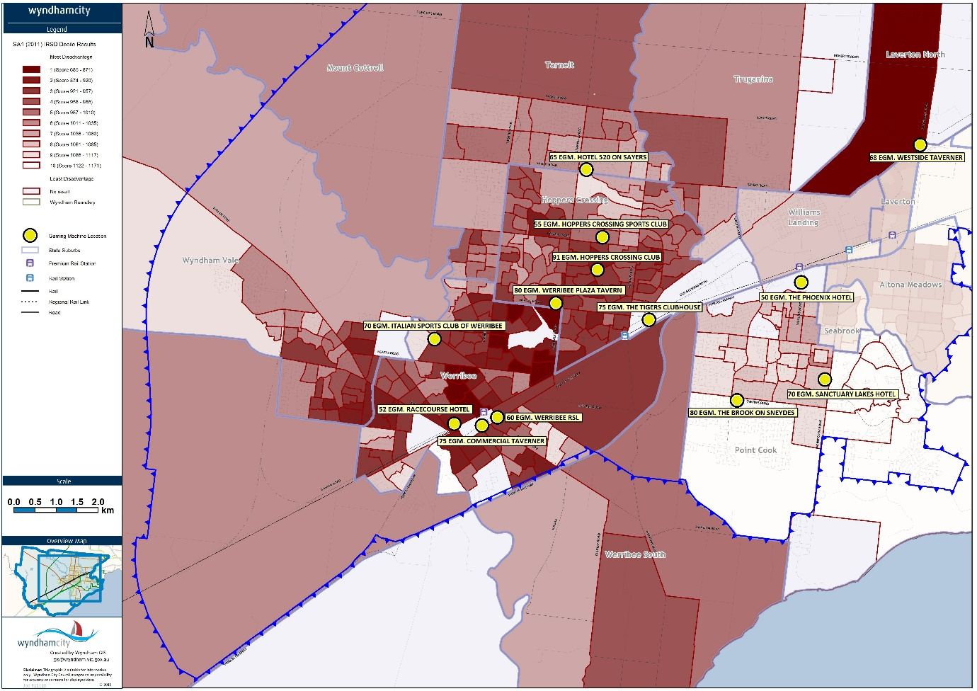

Expenditure: from Wyndham to venues

Wyndham expenditure
Total EGM expenditure in Wyndham in 2016/17 was $97,761,233.60. This is the seventh highest expenditure in Greater Melbourne as the figure below shows.
Figure 1: Total EGM expenditure in Greater Melbourne municipalities, 2016/17
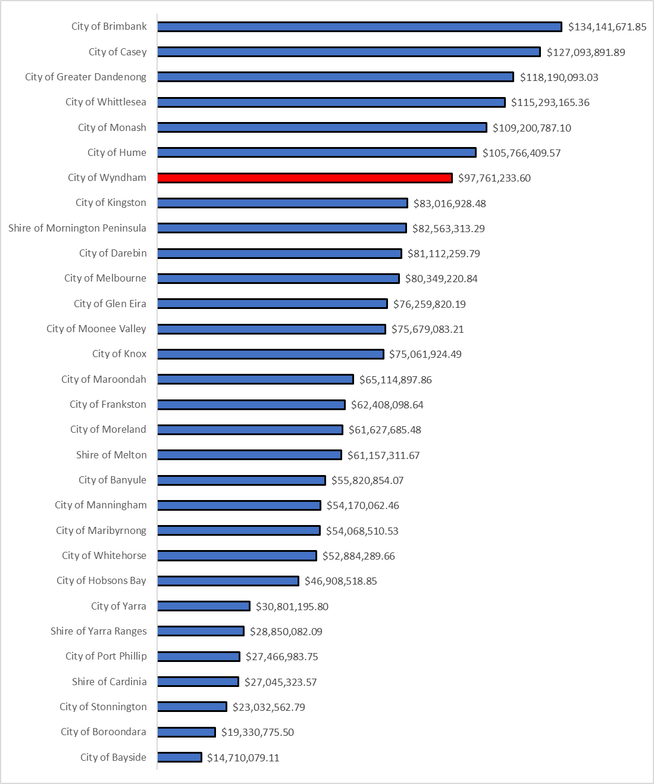
Wyndham has not seen the consistent decrease in EGM expenditure that Greater Melbourne has had between 2002/03 and 2016/17. Between 2002/03 and 2010/11 total EGM spending in Wyndham consistently rose from $81 million to $91 million after which it has remained reasonably level. By contrast, total expenditure across Greater Melbourne has consistently decreased. The levelling off in Wyndham from 2012/13 onwards is at least in part the result of regulatory changes that saw the banning of ATMs in EGM venues.
As the below figure shows Wyndham’s growth in EGM expenditure has been consistently higher than that in Greater Melbourne: Greater Melbourne’s total expenditure grew only in five of the 14 years while Wyndham recorded growth in 11 of the 14 years.
Figure 2: Yearly EGM expenditure growth rates, Wyndham and Greater Melbourne
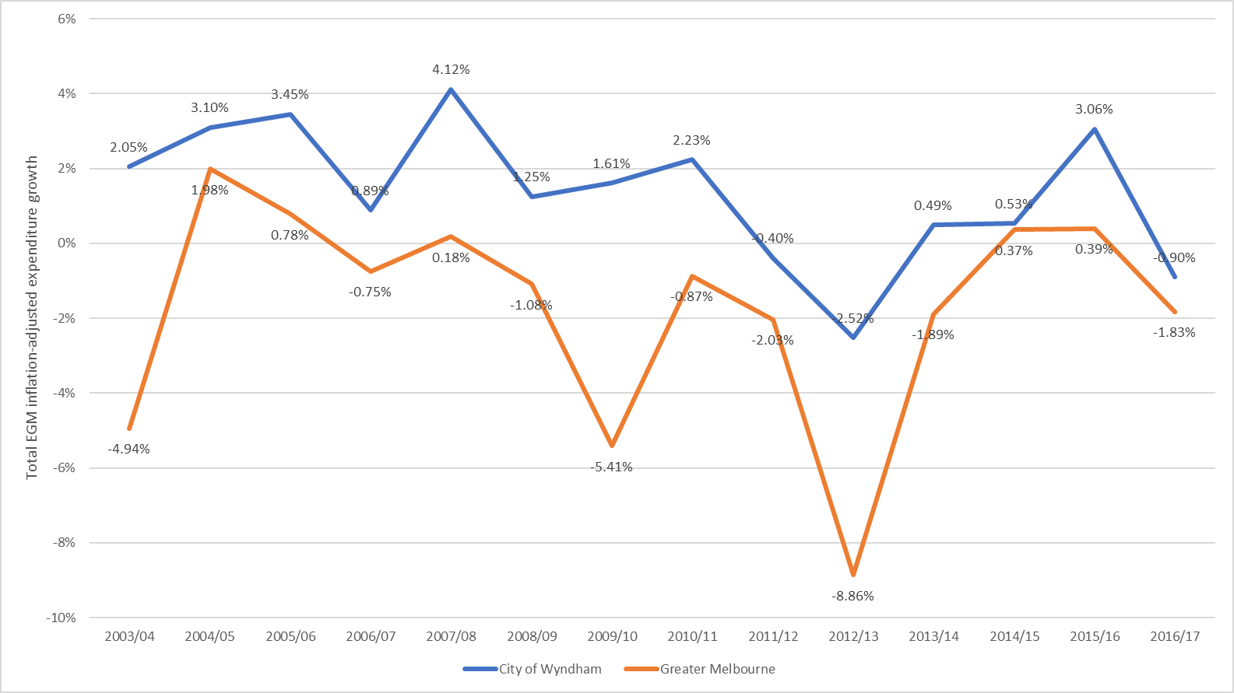

It is possible that a growth in EGM expenditure is affected by the number of EGMs that are available to residents and the large population increase that Wyndham has experienced. The figure below displays the total number of EGMs against total expenditure. It shows that despite an increase in the number of EGMs in 2012/13, there was a decrease in expenditure in that year – most due to the abolition of ATMs in venues. However, in the next four years there was an increase in total expenditure.
Figure 3: Number of EGMs and total EGM expenditure, Wyndham
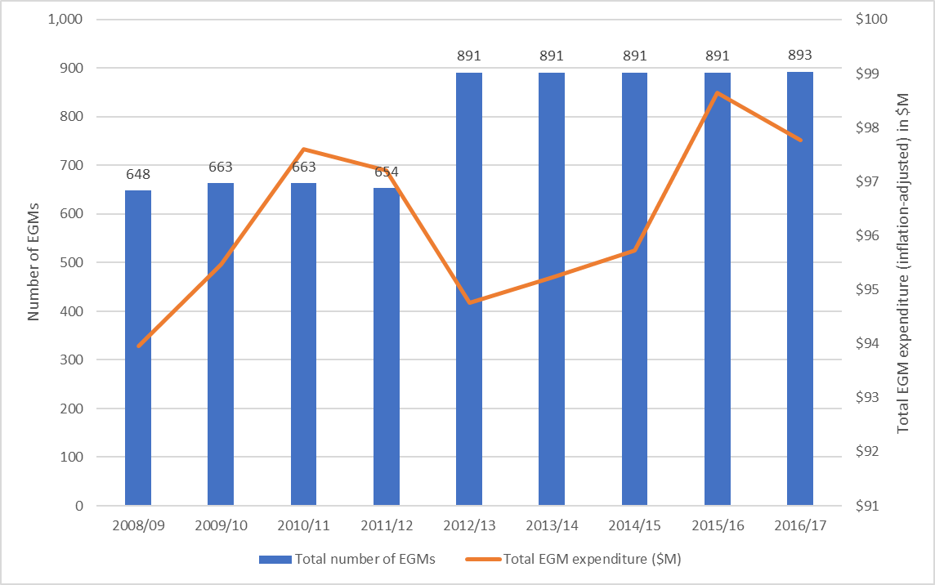

EGM availability has increased in Wyndham between 2008/09 and 2016/17 whereas it has decreased in Greater Melbourne. Despite the increase in EGM availability, average expenditure per adult has decreased as the table below shows. This is in part a result of strong population growth and the small increase in total EGM expenditure (4% between 2008/09 and 2016/17) relative to the increase in the number of EGMs, and possibly due to regulatory and policy changes – the banning of ATMs in particular.
It is not possible to identify expenditure by only those who have EGMs. The decrease in expenditure over all Wyndham adults does not mean that the gambling problem is disappearing; what the figures could be hiding is that fewer adults could be gambling but at a higher rate.

 | Average EGM expenditure per adult |  | Number of EGMs per 1,000 adults
 | Wyndham | Greater Melbourne | Wyndham | Greater Melbourne
2008/09 | $964 | $858.51 | 4.27 | 6.39
2016/17 | $600.55 | $561.07 | 5.49 | 5.25

Expenditure by venue
The seven hotels and six clubs in Wyndham have highly differing EGM numbers and expenditures. The table below summarises the venues’ locations, number of EGMs, player expenditure and recent growth rates in player expenditure.
Venue | Venue type | EGMs | Location | Expenditure 2016/17 | Expenditure per EGM | Expenditure change from 2012/13 to 2016/17
Werribee Plaza Tavern | Hotel | 80 | Hoppers Crossing | $12,848,444 | $160,605.55 | -35.49%
Commercial Taverner | Hotel | 75 | Werribee | $12,490,443 | $166,539.24 | -7.91%
The Tigers Clubhouse | Club | 75 | Hoppers Crossing | $10,494,069 | $139,920.92 | 13.95%
Sanctuary Lakes Hotel | Hotel | 70 | Point Cook | $9,468,177 | $135,259.67 | 152.65%
Hotel 520 on Sayers | Hotel | 65 | Tarneit | $9,168,318 | $141,051.05 | 55.83%
Westside Taverner | Hotel | 70 | Laverton North | $8,950,893 | $127,869.90 | -18.33%
Hoppers Crossing Club | Club | 91 | Hoppers Crossing | $6,040,575 | $66,379.95 | -20.59%
The Phoenix Hotel | Hotel | 50 | Point Cook | $5,702,583 | $114,051.66 | 804.17%
Italian Sports Club of Werribee | Cub | 70 | Werribee | $5,275,078 | $75,358.26 | 10.23%
The Brook on Sneydes | Club | 80 | Point Cook | $5,241,486 | $65,518.58 | -15.72%
Hoppers Crossing Sports Club | Club | 55 | Hoppers Crossing | $4,387,518 | $79,773.05 | 15.48%
Racecourse Hotel | Hotel | 52 | Werribee | $4,384,740 | $84,321.92 | -13.35%
Werribee RSL | Club | 60 | Werribee | $3,308,709 | $55,145.15 | -2.10%
Wyndham total |  | 893 |  | $97,761,234 | $109,475.07 | -3.07%
Greater Melbourne |  | 18,801 |  | $2,046,887,035 | $108,871.18 | -2.87%

While Werribee Plaza Tavern does not have the largest number of EGMs in Wyndham, it does have the highest player expenditure level at almost $13 million. It is closely followed by the Commercial Taverner (75 EGMs) with $12.5 million. The venue with the highest number of EGMs is the Hoppers Crossing Club (91). Its 2016/17 player expenditure was just over $6 million. Of the six venues with the highest total expenditures, five are hotels. The one club in this top six is the Tigers Clubhouse.
Average expenditure per EGM is highest for the Commercial Taverner and Werribee Plaza Tavern. For these venues each EGM brought in over $160,000 in 2016/17. All hotels except the Racecourse Hotel had average expenditure per EGM above the Greater Melbourne average. Only one of the clubs (the Tigers Clubhouse) has average expenditure per EGM above the Greater Melbourne average.

Tax impact
EGM revenue is not only a major aspect of venues’ operations, but also contributes to the Victorian treasury in the form of taxes. Of the $2.6 billion that was spent on EGMs in 2015/16, around 36.7 per cent ($961.3 million) were collected in taxes by the state government.
The Victorian Government has made changes to the tax structure of EGM revenue. These changes will come into effect in August 2022 and are shown in the table below.
 | Current tax structure |  | August 2022 tax structure
 | Monthly average per EGM revenue | Tax rate | Monthly average per EGM revenue | Tax rate
Clubs | Less than $2,666 | 0.00% | Less than $2,666 | 0.00%
 | $2,666 or more and less than $12,500 | 46.70% | $2,666 or more and less than $6,667 | 46.70%
 |  |  | $6,667 or more and less than to $12,500 | 51.17%
 | $12,500 or more | 54.20% | $12,500 or more | 60.67%
Hotels | Less than $2,666 | 8.33% | Less than $2,666 | 8.33%
 | $2,666 or more and less than $12,500 | 55.03% | $2,666 or more and less than $6,667 | 55.03%
 |  |  | $6,667 or more and less than to $12,500 | 57.50%
 | $12,500 or more | 62.53% | $12,500 or more | 65.00%

The impacts of the changes on Wyndham venues will be:
- The total increase in tax revenue the Victorian Government would receive under the new tax regime from Wyndham venues is $884,042.84.
- All hotels are affected by the tax structure changes. The total increase paid by the seven hotels would be $643,171.35.
- Of the six clubs taxes would only increase for the Tigers Clubhouse. Its increase would be $200,871.49.
- The effective tax rate across all Wyndham venues is now 38.6%. In 2022 this would be 39.4% based on 2016/17 EGM revenue.
- The effective tax rate across all hotels would rise from 44.3% to 45.4%.
- For clubs the effective tax rate would rise from 28.2% to 28.8%.
 |  | Tax Total 2016/17 (current tax regime) | Tax Total 2016-17 (2022 tax regime) | Tax increase | Effective tax rate (current tax regime) | Effective tax rate (2022 tax regime)
Hotels
 | Werribee Plaza Tavern | $5,938,911.19 | $6,098,179.86 | $159,268.67 | 46.2% | 47.5%
 | Commercial Taverner | $5,846,004.37 | $6,006,310.91 | $160,306.54 | 46.8% | 48.1%
 | Westside Taverner | $3,879,857.81 | $3,962,547.97 | $82,690.16 | 43.3% | 44.3%
 | Hotel 520 On Sayers | $4,074,208.47 | $4,172,154.54 | $97,946.07 | 44.4% | 45.5%
 | Sanctuary Lakes Hotel | $4,164,519.21 | $4,259,986.29 | $95,467.08 | 44.0% | 45.0%
 | The Phoenix Hotel | $2,391,118.26 | $2,433,117.15 | $41,998.88 | 41.9% | 42.7%
 | Racecourse Hotel | $1,636,028.45 | $1,641,522.40 | $5,493.95 | 37.3% | 37.4%
 | Hotels total | $27,930,647.76 | $28,573,819.12 | $643,171.35 | 44.3% | 45.4%
Clubs
 | The Tigers Clubhouse | $3,780,210.62 | $3,981,082.12 | $200,871.49 | 36.0% | 37.9%
 | Italian Sports Club of Werribee | $1,417,642.75 | $1,417,642.75 | $0.00 | 26.9% | 26.9%
 | Hoppers Crossing Club | $1,461,384.45 | $1,461,384.45 | $0.00 | 24.2% | 24.2%
 | Hoppers Crossing Sports Club | $1,227,256.54 | $1,227,256.54 | $0.00 | 28.0% | 28.0%
 | The Brook on Sneydes | $1,252,552.96 | $1,252,552.96 | $0.00 | 23.9% | 23.9%
 | Werribee RSL | $648,844.59 | $648,844.59 | $0.00 | 19.6% | 19.6%
 | Clubs total | $9.787,891.91 | $9,988,763.41 | $200,871.49 | 28.2% | 28.8%
Total |  | $37,718,539.67 | $38,562,582.53 | $884,042.86 | 38.6% | 39.4%

Community benefits
Besides the tax obligations, clubs are also required to contribute at least 8.33% of their EGM revenue to support the community. Clubs document these contributions in annual Community Benefit Statements lodged with the VCGLR. Clubs have three categories to claim such community benefits as follows:
 | Class A | Class B | Class C
Direct or indirect community benefits | Direct | Indirect | Indirect
Type of claims that can be made | Donations, gifts and sponsorships to another person resident in Victoria. | Capital expenditures above $10,000.  Financing costs (including interest).  Operating costs. | Provision of responsible gambling measures and activities (except those required by law).  Reimbursements for expenses incurred by volunteers.  The preparation and audit of a community benefit statement to a maximum of $3,000.

The table below summarises community benefits that clubs in Victoria and Wyndham have claimed for 2015/16. While all clubs exceed the 8.33% threshold by a sizeable margin, the large majority of community benefits claimed were in Class B in the form of indirect community benefits. Wyndham clubs proportionally spend less on community benefits overall than all Victorian clubs.
 | Victoria | Wyndham
Total community benefits claimed | $283,443,046 | $6,755,194
Community benefits as a proportion of EGM revenue | 31.7% | 19.76%
Class A proportion of community benefits | 22.8% | 17.2%
Class B proportion of community benefits | 77% | 82.6%
Class C proportion of community benefits | 0.2% | 0.17%

Most clubs have relied on expenses under Class B – which allows operational expenses – to comply with or exceed the community benefits threshold. The figure below shows the extent to which the clubs rely on Class B benefits. On average, clubs rather consistently spent 17% of community benefits on activities under Class A, 82.8% on activities under Class B, and 0.2% under activities in Class C. None of the five clubs have lodged anything other than their auditing expenses under Class C. They have the option to lodge costs from the provision of responsible gambling measures and activities (excluding what is legally required); none of the clubs have done so.
None of the clubs’ expenses under Class A exceed the minimum threshold. The expenses range between 16% of the threshold (The Brook on Sneydes) and 55% of the threshold (Hoppers Crossing Sports Club).
 | Community benefits (2015/16)
 | Threshold | Total spent | Class A | Class B | Class C
Hoppers Crossing Club | $543,644 | $1,388,031 | 14.70% | 85.20% | 0.10%
 |  |  | ($203,709) | ($1,182,322) | ($2,000)
Hoppers Crossing Sports Club | $323,427 | $545,086 | 32.90% | 66.60% | 0.60%
 |  |  | ($180,270) | ($362,816) | ($3,000)
Italian Sports Club Werribee | $431,604 | $1,272,212 | 15.50% | 84.30% | 0.20%
 |  |  | ($197,352) | ($1,072,385) | ($2,475)
The Brook on Sneydes | $419,423 | $963,124 | 7.00% | 92.90% | 0.10%
 |  |  | ($67,229) | ($894,895) | ($1,000)
The Tigers Clubhouse | $873,283 | $2,192,170 | 14.80% | 85.10% | 0.10%
 |  |  | ($325,054) | ($1,865,121) | ($1,995)

As a last illustrative point, the table below shows the broad categories that the clubs have claimed expenses under in Class B. Generally, wages account for 55% to 80% of the clubs’ expenses under Class B. All but one club (Hoppers Crossing Sports Club) lodge wage expenses under Class B to such an extent that they exceed the minimum community benefits threshold. So, if the clubs were so inclined, all but one could lodge community benefits statements consisting entirely of expenses under Class B.
 | Percentage of total community benefits claimed in Class B
 | Wages | Rates & Taxes | Lease Payment | Capital | Other Costs
Hoppers Crossing Club | 72.90% | 1.40% | 0.00% | 0.00% | 25.60%
Hoppers Crossing Sports Club | 55.90% | 0.00% | 0.00% | 0.00% | 44.10%
Italian Sports Club Werribee | 80.00% | 0.30% | 0.00% | 1.00% | 18.70%
The Brook on Sneydes | 66.20% | 1.80% | 29.80% | 2.20% | 0.00%
The Tigers Clubhouse | 68.20% | 0.00% | 24.20% | 0.00% | 7.50%

Online Gambling
New developments in digital technologies have resulted in changes to how and where people gamble. Online gambling or internet gambling is essentially any gambling that occurs via the internet whether that is via a computer, mobile phone or other devices.
Online gambling is regulated by the Commonwealth Government through the Interactive Gambling Act 2001 (IGA). The IGA targets the providers of interactive gambling services. It is an offence to provide interactive gambling service to Australian customers. However, (the Act) does not prohibit access to online services, this means access to online gambling can be provided by overseas companies.
Online gambling can include the following:
- Online wagering – consisting of racing and sports betting
- Online gaming – poker, blackjack, baccarat, roulette and virtual EGMs
- Lotteries – such as Tattslotto, Ozlotto and Keno.

This increased accessibility to gambling, achieved via growth in online technologies, may explain the increasing rates of participation in online gambling. For instance:

- The Study of Gambling and Health in Victoria showed that participation in gambling online increased from 4.2 per cent in 2008 to 10 per cent in 2011

- Results from a national survey examining interactive gambling from 2010/11 found that 8.06% of Australians had participated in online gambling in the past year

- The Study of Gambling and Health in Victoria showed that participation in sports betting online is increasing, with 52% of sports gamblers placing bets online during the previous 12 months.

While figures on the number of Australians with betting accounts are not publicly available, the following information has been obtained from wagering providers:
- William Hill –284,000 active account holders in Australia
- Tabcorp – increase of 12% in number of active account holders in 2014/15Ladbrokes – staking up 47%, net revenue up 54%, actives up 65%.
- Ladbrokes notes that in 2015 ‘Australia has been one of our strongest performing businesses and, despite strong competition in this market, it delivered net revenue up 70.9% in the year

Council is concerned about the harmful impacts of all forms of gambling, and the growing participation in online gambling, however its ability to influence falls outside the direct influence of local government legislation as this is the domain of Federal and State governments. Council is particularly concerned with the impacts of online and sports betting on young people and calls for more research in this space.
Council has a responsibility and will continue to advocate at both the State and Federal levels for legislative and regulatory changes in this space.

Glossary
EGM: an electronic gaming machine is a computerised gambling device that has a video screen displaying symbols on simulated reels. Cash is inserted into the machine and buttons are used to place bets. The machine randomly determines the position of symbols on the screen. Wins are returned as credits back into the machine.
VCGLR: Victorian Commission for Gambling and Liquor Regulation, the independent statutory authority which regulates Victoria's gambling and liquor industries. The commission conducts hearings (both public and private) on matters such as approval for proposed gaming premises, or requests for increased gaming machines.
VCAT: Victorian Civil & Administrative Tribunal is a tribunal that hears and decides civil and administrative legal cases in Victoria.
SEIFA IRSD: a product developed by the ABS that ranks areas in Australia according to relative socio-economic advantage and disadvantage. The indexes are based on information from the five-yearly Census. The four indices are constructed from Census variables and each measure describes a slightly different feature of personal socio-economic conditions in an area.
Community benefits: contributions that clubs are legally obliged to support the community. Clubs are required to contribute at least 8.33% of their EGM revenue to support the community. Clubs document these contributions in annual Community Benefit Statements that are lodged with the VCGLR. Clubs can claim expenditures under three classes:
- Class A consists of direct community benefits in the form of donations, gifts and sponsorships to another person resident in Victoria. This can include cash and (non-alcoholic) goods and services. Clubs may claim 100% of the expenditure in this category as community benefits.
- Class B consists of indirect community benefits, which the Order indicates to encompass capital expenditures above $10,000, financing costs (including interest), and operating costs. Clubs may claim the amount equivalent to the proportion of revenue made from non-gaming sources to the club’s total revenue.
- Class C is a miscellaneous item which consists of the provision of responsible gambling measures and activities (except those required by law), reimbursements for expenses incurred by volunteers, and the preparation and audit of a community benefit statement to a maximum of $3,000. Clubs may claim 100% of expenses in this class as community benefits.
Low risk gamblers: are defined as those scoring a 1 to 3 on the Problem Gambling Severity Index, a questionnaire that helps estimate a person’s risk of gambling problems and the harm resulting from them.
Moderate risk gamblers: are defined as those scoring 4 to 7 on the Problem Gambling Severity Index, a questionnaire that helps estimate a person’s risk of gambling problems and the harm resulting from them.
Problem gamblers: are defined as those who have experienced adverse consequences as a result of their gambling. Problem gamblers have scores of 8 or more on the Problem Gambling Severity Index, a questionnaire that helps estimate a person’s risk of gambling problems and the harm resulting from them.
VLGA: Victorian Local Governance Association is an independent organisation that supports councils, councillors and communities in good governance.
Gambling: Gambling refers to any activity associated with gambling, including gambling on electronic gaming machines and online gambling.
Burden of disease: Is the impact of a health problem as measured by financial cost, mortality. Morbidity, or other indicator. It is often quantified in terms of quality-adjusted life years or disability-adjusted life years, both of which quantify the number of years lost due to disease.

Browne, M, Langham, E, Rawat, V, Geer, M, Li, E, Rose, J, Rockloff, M, Donaldson, P, Thorne, H, Goodwin, B, Bryden, G & Best, T 2016, Assessing gambling-related harm in Victoria: a public health perspective, Victorian Responsible Gambling Foundation, Melbourne.
Australian Bureau of Statistics 2016, Regional Population Growth 2014-15
Wyndham Population and Household Forecasts 2011-2036
Australian Bureau of Statistics, Census of Population and Housing 2016 and Wyndham City Council, Wyndham Snapshot June 2017
ID Consulting, City of Wyndham Economic Profile, Unemployment, September 2016
Wyndham City Council 2016, Housing Stress and Homelessness Profile
Crime Statistics Agency 2016, Family Incidents Data Tables
Electronic gaming machines are a synonym for pokies. They are a computerised gambling device that has a video screen displaying symbols on simulated reels. To operate cash is inserted into the machine and buttons are used to place bets. The machine randomly determines the position of symbols on the screen. Wins are returned as credits back into the machine.
Browne, M, Langham, E, Rawat, V, Geer, M, Li, E, Rose, J, Rockloff, M, Donaldson, P, Thorne, H, Goodwin, B, Bryden, G & Best, T 2016, Assessing gambling-related harm in Victoria: a public health perspective, Victorian Responsible Gambling Foundation, Melbourne.
Miller, H (2017) Hidden harm: Low-risk and moderate-risk gambling, Victorian Responsible Gambling Foundation, Melbourne.
Hare, S. (2015) Study of Gambling and Health in Victoria, Victoria, Australia: Victorian Responsible Gambling Foundation and Victorian Department of Justice and Regulation.
The categories for risk of gambling harm used are based on the Problem Gambling Severity Index. This is a questionnaire that helps estimate a person’s risk of gambling problems and the harm resulting from them.
All data in this section comes from the VCGLR unless otherwise indicated. ABS CPI data was used to adjust for inflation.
Hare, S. (2015) Study of Gambling abd Health in Victoria, Victoria, Australia: Victorian Responsible Gambling Foundation and Vicotrian Department of Justice and Regulation.
Sally Gainsbury, Alex Russell, Nerilee Hing, Robert Wood, Dan Lubman, Alex Blaszczynski (2013). ‘How the internet is changing gambling: findings from an Australian prevalence survey’ Journal of Gambling Studies.
Hare, S. (2015) Study of Gambling and Health in Victoria, Victoria, Australia: Victorian Responsible Gambling Foundation and Victorian Department of Justice and Regulation.
William Hill PLC, Annual Report and Accounts 2016, pg. 28
Tabcorp concise Annual Report 2015, pg. 2
Ibid, pg. 15

